Find a painting by Lowry and sketch it here. Note its title and the date it was painted.

Why did you choose this painting?
___________________________________________________________________________________________________________________________

L S Lowry

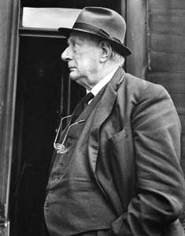

When and where was he born?
__________________________________________________________________________________

What subject matter did he choose to paint and draw?
__________________________________________________________________________________
__________________________________________________________________________________

What influenced this subject matter? (Why did he choose to draw and paint what he did?) ____________________________________________________________________________________________________________________________________________________________________

How does Lowry use colour in his work?
__________________________________________________________________________________
__________________________________________________________________________________

What feelings do you have about Lowry’s work?
____________________________________________________________________________________________________________________________________________________________________

Would you like to have one of paintings on your wall? Explain your decision.
____________________________________________________________________________________________________________________________________________________________________

What else have you found out about Lowry?
_____________________________________________________________________________________________________________________________________________________________________________________________________________
____________________________________________________________________________________________________________________________________________________________________

