Making Escher Patterns Stage ONE

Take a small rectangular piece of card
- Draw a shape on one end of the card only
- Cut out the shape and sellotape it (no overlaps) onto the opposite end of the card to form a template.

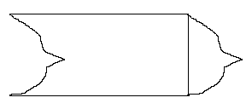
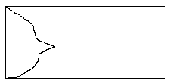
Drawing Template

- Look at the template from all angles to decide what it looks like (this one looks like a fish)
- Use the template to cover a sheet of paper (A3) with tessellating shapes
- Draw in features so that each tile is slightly different
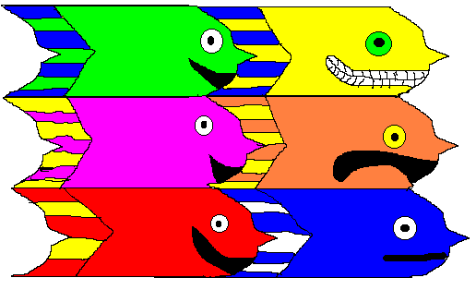
- Colour in felt pen

Making Escher Patterns Stage TWO

Take a small rectangular piece of card
- Draw a shape on one end of the card only
- Cut out the shape and sellotape it (no overlaps) onto the opposite end of the card to form a template.
- Then do the same on the top of the card, sticking the cut-out onto the bottom
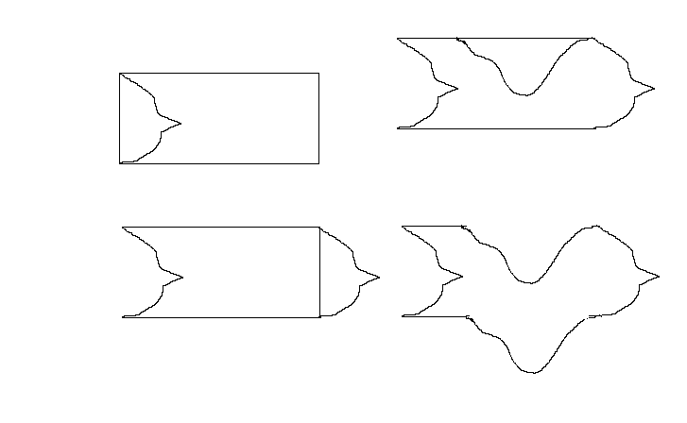

- Look at the template from all angles to decide what it looks like (this one looks like a bird or, on its side it looks like an animal or person)
- Use the template to cover a sheet of paper (A3) with tessellating shapes
- Draw in features so that each tile is slightly different
- Colour in felt pen
