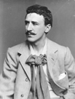
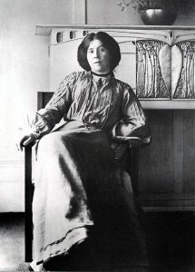
Charles Rennie Mackintosh

Charles Rennie Mackintosh was born one of eleven children in the Townhead area of Glasgow, close to Glasgow Cathedral. He was a Scottish artist and also an architect, which means he designed buildings too.
He met Margaret Macdonald, his wife, at Glasgow School of Art and they started to work together on buildings, furniture and paintings.
Mackintosh took his inspiration from Scottish traditions, modern shapes and Japanese forms.
During his life Charles moved to Chelsea in England and to France. He painted landscapes. Charles died in 1928 in London and Margaret a few years later in 1933.
In Glasgow you can see many buildings that the husband and wife designed like the Scotland Street School and Willow Tea Rooms. They are beautiful and people travel from all over the world to visit them. Many people wear Charles Rennie Mackintosh style jewellery and you can see some in the shops and maybe on someone you know!
Questions:
- How many brothers and sisters did Charles have?
- Which area of Glasgow was he born in?
- What was he famous for?
- Which three countries did Charles and Margaret live in?
- Who was Margaret MacDonald?
- Where can we go to see one of Charles Rennie Mackintosh’s buildings?
- How many years ago did Charles die?
- Who could you ask if they have any MacKintosh jewellery?
- Would you like Charles Rennie Mackintosh to design our classroom? What would he put in it?

