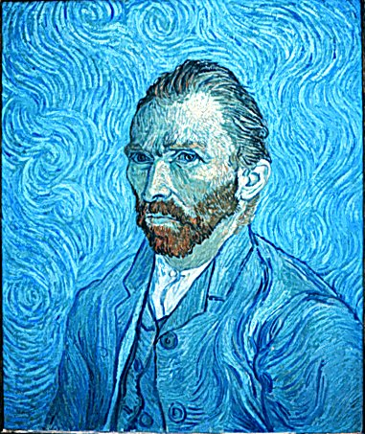
Vincent Van Gough
How does this person look? How do you think they feel?

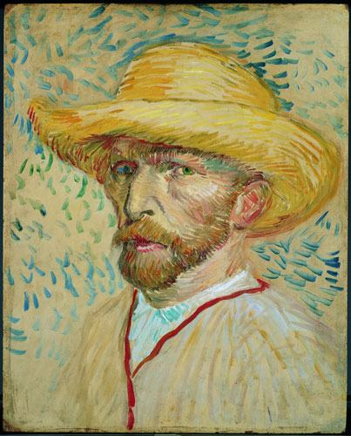
How does this person look?
Is it similar or different from the first picture?
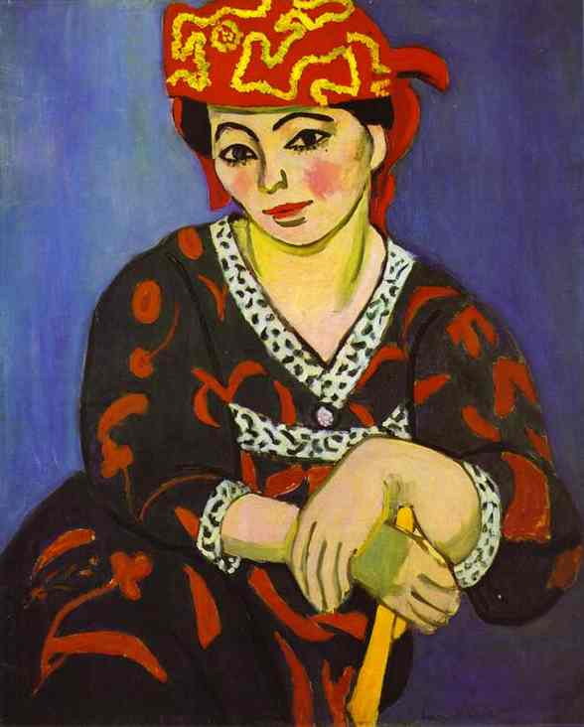
Henri Matisse
How does the lady look?
How do you think she feels?

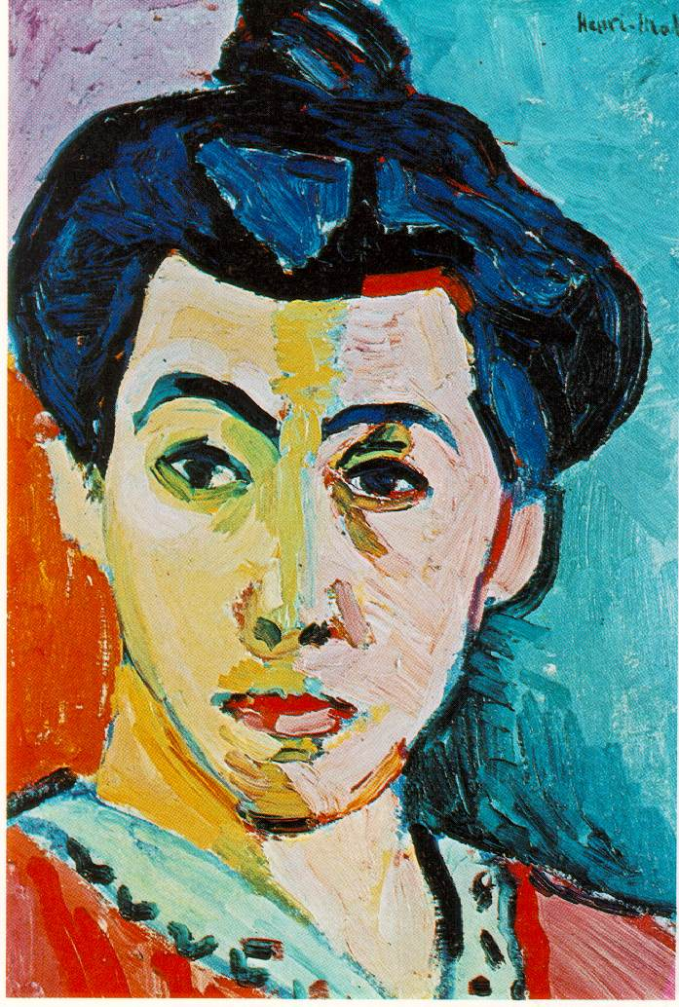

How does the lady look?
How do you think she feels?
Is it similar or different from the first picture?

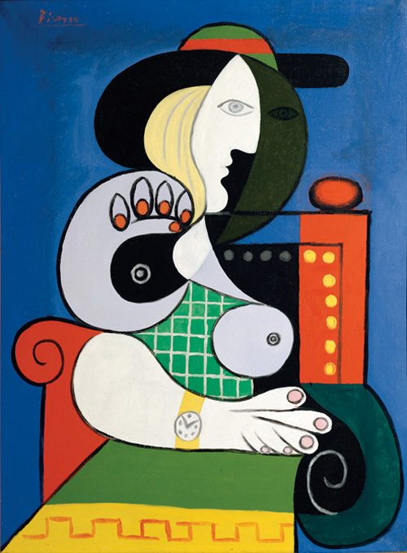
Picasso
What is the mood of this person?

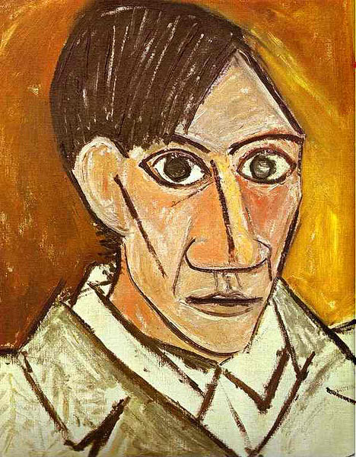
How old do you think this man is?
How do you think he feels?
How does he make you feel?

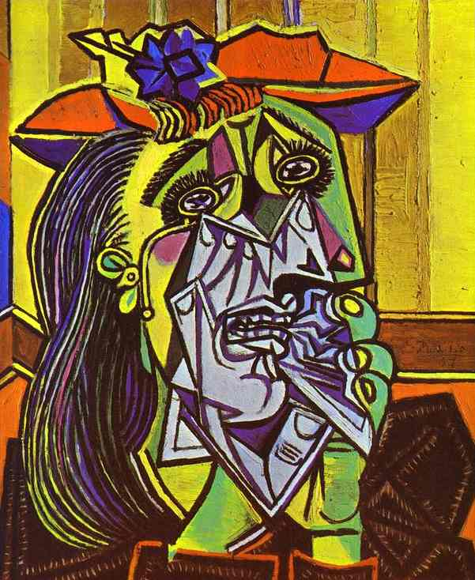
How does this woman feel?
How does the portrait make you feel?

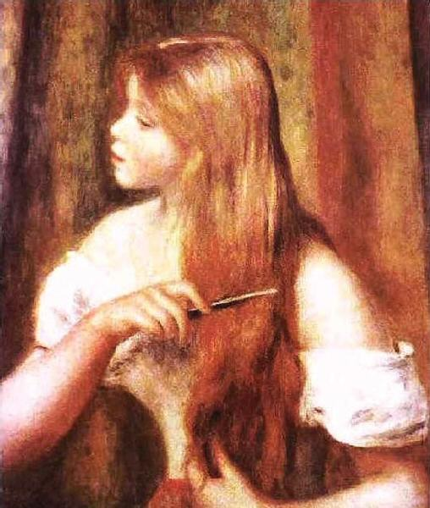
Renoir
What is this ladies face telling you about her?
How does the portrait make you feel?

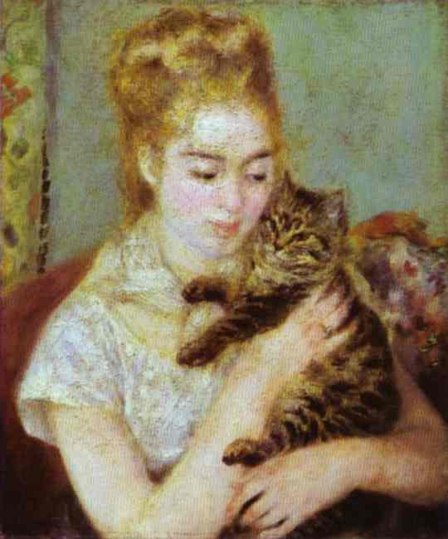
How old is the lady?
How does this person feel?

Which painting did you prefer? Why?
Describe the person in the portrait.
How old are they?
Are they a man or a lady?
What impression does their face say about them?
What do you like/dislike about the picture?

