Mother Donkey’s Story

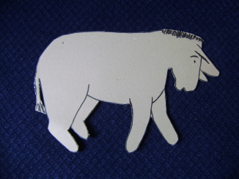
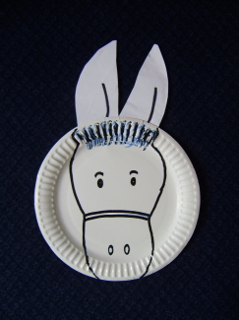

Props
Two cardboard donkeys for children to hold up

This is a Bible story and we don’t really know the donkeys names and having them talking is just a bit of fun

This is a story about a little donkey called Kidron. He had been growing fast, and he was nearly as big as his mum now.
This is his mother, Tabitha. She was very proud of her son. He was growing into a fine strong donkey. He was nearly ready for someone to ride on him now. She wondered how he would get on. Every time someone tried to get on his back, he bucked and bolted and tried to throw them off. She laughed to herself in a donkeyish kind of way (hee haw hee haw). But their master was very good at training donkeys!
What Tabitha didn't know was that someone was going to ride her little Kidron very soon now!
Later on that day, just as they were finishing a nice few mouthfuls of grass, two men came along and started to untie them.
"Someone’s stealing us!" thought Tabitha. "How dare they, hee haw hee haw. Where is our master?"
But just then, the master came out of his house.
"What are you doing?" he said. "Why are you untying my donkeys?"
The two men replied, "The Master needs them".
"Which Master's that?" thought Tabitha. "Do these two men have a master too?"
Anyway, Tabitha’s master seemed to know all about it. He was smiling to himself. And the two men took the two donkeys and led them down the road. There was quite a crowd of people down there. And then suddenly, Tabitha knew who their master was.
"Look!" she said to Kidron. "Hee haw hee haw, it's our friend Jesus!" Jesus was patting the two donkeys and talking to them.
"Can I ride on you today?" Jesus asked Kidron.
"Uh oh", thought Tabitha. "Here comes trouble."
But as she watched, Jesus got on Kidron's back, and he just stood there, as quiet as quiet. Then he started to carry Jesus proudly down the road.
Everyone started cheering. "Hosanna, Hooray for Jesus, God bless our King". People threw their coats and cloaks in the road.
"Oh good" thought Tabitha. "I know it's for Jesus, but it's nice for Kidron’s feet too. He's not used to walking on the hard road yet." And so Kidron carried Jesus all the way into Jerusalem town. "Just fancy," Tabitha said to herself. "The Romans ride into cities on big mighty warhorses, but our King Jesus is arriving in Jerusalem on our little Kidron!" She was the proudest mother donkey in the whole world!

Puppet
Lucy Don't I look beautiful today? Don't you think that my hair looks shiny and lovely? And isn't my dress beautiful?
Ruth Lucy! That is not like you! You sound quite proud when talk like that!
Lucy Well I always thought it was wrong to be proud.
Ruth So what has changed your mind?
Lucy You said that the mother donkey was proud of her little donkey, and you made it sound good
Ruth Oh I see! Let me see if I can explain it to you. It is bad to be proud and boast about things, like, "I'm really good at football."
Lucy But it is OK to be proud about some things , is it?
Ruth Yes, you can be proud about good things that God has given you, but don't keep talking about them all the time!
Lucy Like I am proud of my puppy when he is good. Is that what you mean?
Ruth Yes, that is good
Lucy And why did he ride on a donkey?
Ruth You mean, why did Jesus ride on a donkey?
Lucy Yes, why didn't he ride a great big, big horse? 'Cos Jesus was more important than all those Romans, wasn't he?
Ruth I think that he wanted to show everyone that he was the Prince of Peace. He did not come for war, so he did not ride on a warhorse.
Lucy The Romans had big armies, didn't they?
Ruth Jesus came to serve people, not to push people around. He wanted to be their friend
Lucy Oooh. I am glad that he is my friend!

Prayer
Thank you dear God / that Jesus is / the Prince of Peace / and thank you that / He wants to be our friend / Amen

