Peter is happy

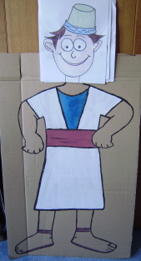

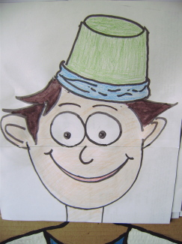
2
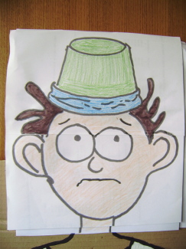
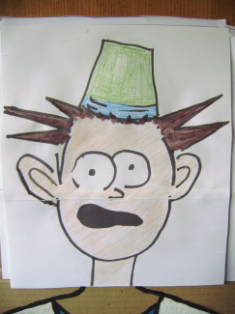
4
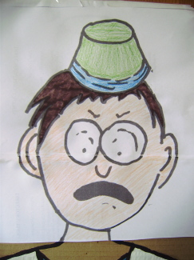

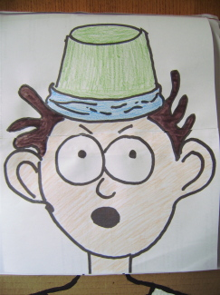
6
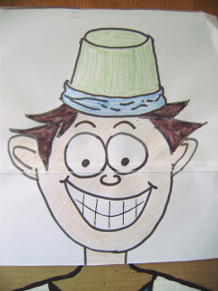

Props
Flip chart with six sheets, each showing Simon Peter's face with a series of different expressions:- happy, worried, frightened, very sad, surprised, very happy. Alarm clock that makes the sound of a cockerel if you have one

1. Peter was happy. They were going to have a party. It was a special holiday for the Jewish people. Peter and Jesus and their other friends were all Jewish, you know. And so they were going to have a lovely meal together. It was called Passover. They ate special flat bread and lots of other lovely food. Peter and Jesus were both looking forward to it.

They had a wonderful time. After they had finished all the food, they ended up talking until very late in the evening. They loved to ask Jesus questions and then listen to his answers. He seemed to know everything! But at the end of the evening, Jesus got rather serious. He started saying mysterious things like, "I am going away and you won't see me, but then you will see me again". Then he said "I am going to die and then I will come alive again". They did not know what he was talking about.

2. Peter was worried, especially when Jesus said "All of you will run away and leave me". Peter said, "Jesus, I will never leave you. Even if everyone else leaves you, I never will!" Jesus smiled sadly at Peter and he said, "I tell you, Peter, that before the cock crows tonight, you will say three times that you do not know me."

Then Jesus said to them all, "Come on, let's go for a walk." It was dark outside by now, but it was holiday time so there were lots of people outside. They went to a pretty little park they knew. Jesus said, "I need to pray. Will you wait with me?" Jesus knelt down on the ground and started to pray. Jesus knew that he was going to die the next day, so he was talking to God his Father. But Peter was sleepy after that big meal, so he rested his head against a tree and he fell asleep. When he woke up, some men had arrived. Peter suddenly realised that they were soldiers, and they were taking Jesus away!

Peter was so worried. What was going to happen to his dear friend Jesus? Peter followed the group of soldiers as they hurried Jesus along the road. But Peter took good care not to be seen. Jesus was taken into the High Priest's house. Peter slipped quietly into the backyard. It was a big yard and there were lots of people there. They had lit a bonfire because it was a cold night. Peter was very cold after falling asleep in the park, so he went over to the fire. One of the women looked straight at Peter, and then she said to her friends, "This man was with Jesus!"

3. Peter was so frightened! He thought that he might be killed as well as Jesus. So he said the first thing that came into his head. He said, "I'm sorry, ma'am, I don't even know him!"

A little while later, a man noticed Peter and he said, "You are one of them! You talk like Jesus. You've got the same accent". Again, Peter was so frightened. He said, "No, I'm not".

About an hour later, another man said to Peter, "Didn't I see you in that park with Jesus?" This time, Peter was so frightened that he swore and said a bad word, and said, "Man, I don't know what you are talking about!"

Just then, a cock crowed, and Peter suddenly remembered what Jesus had said about denying him three times. He went out and he cried and cried and cried.

4. Peter was so sad. He knew now that Jesus was going to be killed, and he also knew that he had let him down. Jesus’ other friend, John, followed Jesus and the soldiers when they took Him to the cross. Peter just went to the house where they were staying and hid there. John found Peter and told him all about it. Jesus, their best friend, their Lord and Master, was dead. Peter could hardly believe it. It had seemed as if Jesus would never die!

Two days later, Peter was still hiding. Then some of the women came running in and said that the tomb, the cave where they had put Jesus’ body, was empty!

5. Peter was surprised. Jesus’ body was gone. Peter got up and started running to the tomb. John started running too. But John could run faster than Peter and he got there first. They both looked into the cave. It really was empty! Then they went back to where they were staying. John understood what had happened. He knew that Jesus was alive again. But Peter didn't understand yet.

That evening, all of Jesus’ friends were together. They'd locked the door because they were afraid that someone might want to arrest them too. Suddenly Jesus arrived in the middle of the room, even though the door was still locked.

6. Peter was so happy that Jesus was alive. Then Jesus ate some supper with them. After that, for the next few weeks, they saw him lots of times.

On one occasion, Peter had gone fishing in his fishing boat very early in the morning. Jesus was waiting for them on the shore of the lake and Jesus cooked some breakfast for them. After they had finished eating, Jesus and Peter were sitting next to each other by the side of the lake, talking to each other.

Jesus said to Peter, "Peter, am I really your best friend?" Peter answered, "Yes, Lord, you know that you are!"

Then Jesus asked him again, "Peter, am I your best friend?" Peter was surprised when Jesus asked him again. He said, "Yes, Lord, of course you are!"

Then Jesus asked Peter a third time, "Peter, am I your friend?" Peter was worried. He said , "Lord, you know everything. You know that we are friends". Then Jesus said to Peter, "Ok then. I have got a special job for you to do. I want you to take care of all my other friends and my followers. Please look after them all, especially the children."

Peter was so happy. Peter realised that Jesus really loved him. Jesus had forgiven him for letting him down. He had given him a special job to do. A big grin spread all over his face. He knew that he had got it all wrong before, but Jesus still trusted him. He was so happy because he was with Jesus

Puppet

Lucy I'm sad
Ruth Why?
Lucy My friends wouldn't play with me
Ruth Why wouldn't they?
Lucy Don't know. They all just ran away and left me.
Ruth That's what happened to Jesus!
Lucy It must have been horrible for Jesus when all his friends left him!
Ruth Yes. Even Peter left him, who had said that he would never ever leave Jesus
Lucy Yes. It was three times, wasn't it?
Ruth Yes, it was three times that Peter denied Jesus.
Lucy Why did he do that?
Ruth I expect that he was scared that they might kill him too
Lucy Ooooh. I'd have been scared too. I expect I'd have said the same
Ruth Then do you know what happened afterwards, when Jesus was alive again?
Lucy I expect that Jesus didn't want Peter to be his friend any more
Ruth Ah, but he did! Jesus asked Peter three times if he was still his friend. He didn’t even tell him off.
Lucy Why did he ask him three times? Did Peter mind?
Ruth Well, a bit!
Lucy Oh !...... do you think it was......? I suppose it could have been.....?
Ruth What are you trying to say, Lucy?
Lucy Well, Peter had said that he did not know Jesus 3 times over....
Ruth And then he told Jesus 3 times over that he was his friend
Lucy So they made it all alright again! I'd better go and make it alright with my friends! Bye!

