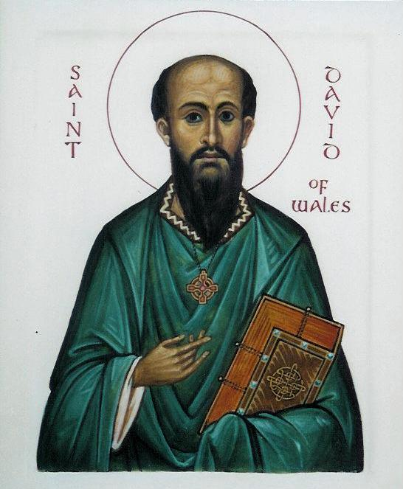

St. David or Dewi Sant

- Saint David, or Dewi Sant, as he is known in the Welsh language, is the patron saint of Wales. He was a Celtic monk, abbot and bishop, who lived in the sixth century. During his life, he was the archbishop of Wales, and he was one of many early saints who helped to spread Christianity.

- Dewi died in the sixth century. He was a very gentle person who lived a poor life. It is claimed that he ate mostly bread and herbs. Despite this poor diet, he was tall and physically strong. Dewi would have probably been a vegetarian, and It is claimed that Dewi lived for over 100 years, and it is generally accepted that he died in 589.

- Dewi was born in Wales. We know a little about his early life - he was educated in a monastery called Hen Fynyw, he stayed there for many years.

- Dewi travelled far on his missionary journeys through Wales, where he established several churches. He also travelled to the south and west of England and Cornwall as well as Brittany. It is also possible that he visited Ireland.

- He founded a monastery where the cathedral city of St. David stands today. The monks were very strict. They worked very hard besides praying. They had to get up very early in the morning for prayers and afterwards work very hard to help maintain life at the monastery. The monks had to keep themselves fed as well as the many pilgrims and travellers who needed lodgings. They also had to feed and clothe the poor and needy in their neighbourhood.

- There are many stories regarding Dewi's life. It is said that he once rose a boy from death, and milestones during his life were marked by the appearance of springs of water.

- St. David was, and is, a very important figure to the Welsh. Naturally, then, St. David's Day is a time of great celebration in Wales. Societies all over Wales celebrate with special meetings and events. In St. David's Hall, Cardiff, each March 1st, there will be a concert featuring a 1000-member male voice choir, specially formed for the occasion.

- St David's Day, as celebrated today, dates back to 1120. His last words to his followers were 'Be joyful, and keep your faith'. Well, we hope that you now have some idea of who St. David was, and why he is so important to us all.

- Let us pray.

Dear Lord,
May we act and be like St. David – Dewi in how he cared for other people in his daily life. May we also try and be more kind and caring.
We make this prayer in Jesus’ name. Amen.

