1. Eyes on speaker
2. Lips closed

3. Ears listening

4. Sit up straight
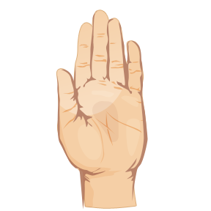
5. Hands and feet quiet

