xxxxxxxxx
JUNIOR SCHOOL

Individual Target
Setting Booklet

Name:

BOOKLET GRADING SYSTEM
Grades are given at the end of each lesson, after the pupil has entered their self assessment face, these grades relate to the set targets on the next page

ACHIEVEMENT
A* Outstanding
A Very Good
B Good
C The standard expected at xxxxxx school
D Below the standard expected at xxxxxxx school
EFFORT
1. Excellent
2. Very Good
3. Good- the minimum level expected of pupils at xxxx school
4. Occasionally below the minimum level expected of pupils at xxxx school
5. Frequently below the minimum level expected of pupils at xxxx school

TARGETS
These are the targets that I will be working to achieve in each lesson

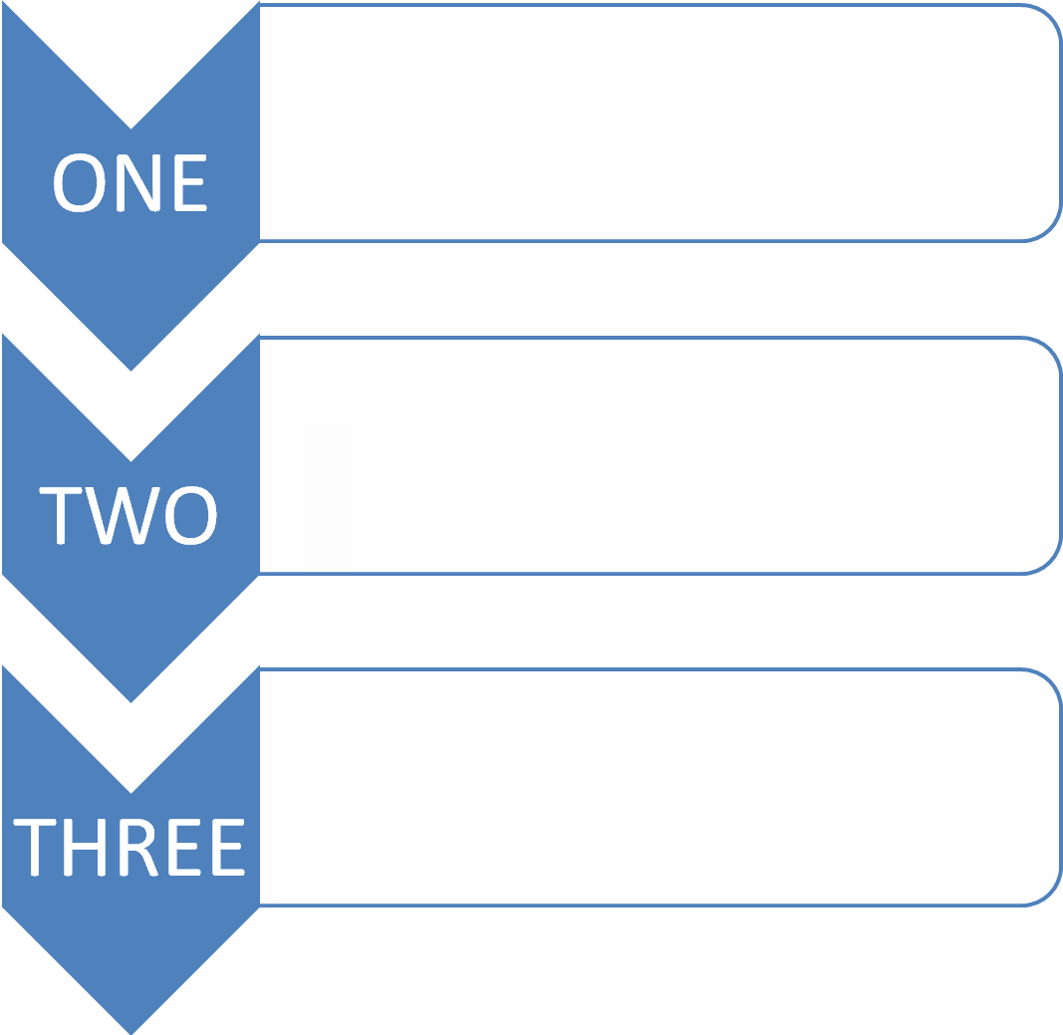

MONDAY
lesson | Comment | Teacher  Grade | Self Evaluation
1 |  |  | ☺ 😐 ☹
2 |  |  | ☺ 😐 ☹
3 |  |  | ☺ 😐 ☹
4 |  |  | ☺ 😐 ☹
5 |  |  | ☺ 😐 ☹
6 |  |  | ☺ 😐 ☹
7 |  |  | ☺ 😐 ☹
8 |  |  | ☺ 😐 ☹
9 |  |  | ☺ 😐 ☹

Parent Comment and Signature
Teacher Comment and Signature

TUESDAY
lesson | Comment | Teacher  Grade | Self Evaluation
1 |  |  | ☺ 😐 ☹
2 |  |  | ☺ 😐 ☹
3 |  |  | ☺ 😐 ☹
4 |  |  | ☺ 😐 ☹
5 |  |  | ☺ 😐 ☹
6 |  |  | ☺ 😐 ☹
7 |  |  | ☺ 😐 ☹
8 |  |  | ☺ 😐 ☹
9 |  |  | ☺ 😐 ☹

Parent Comment and Signature
Teacher Comment and Signature

WEDNESDAY
lesson | Comment | Teacher  Grade | Self Evaluation
1 |  |  | ☺ 😐 ☹
2 |  |  | ☺ 😐 ☹
3 |  |  | ☺ 😐 ☹
4 |  |  | ☺ 😐 ☹
5 |  |  | ☺ 😐 ☹
6 |  |  | ☺ 😐 ☹
7 |  |  | ☺ 😐 ☹
8 |  |  | ☺ 😐 ☹
9 |  |  | ☺ 😐 ☹

Parent Comment and Signature
Teacher Comment and Signature

THURSDAY
lesson | Comment | Teacher  Grade | Self Evaluation
1 |  |  | ☺ 😐 ☹
2 |  |  | ☺ 😐 ☹
3 |  |  | ☺ 😐 ☹
4 |  |  | ☺ 😐 ☹
5 |  |  | ☺ 😐 ☹
6 |  |  | ☺ 😐 ☹
7 |  |  | ☺ 😐 ☹
8 |  |  | ☺ 😐 ☹
9 |  |  | ☺ 😐 ☹

Parent Comment and Signature
Teacher Comment and Signature

FRIDAY
lesson | Comment | Teacher  Grade | Self Evaluation
1 |  |  | ☺ 😐 ☹
2 |  |  | ☺ 😐 ☹
3 |  |  | ☺ 😐 ☹
4 |  |  | ☺ 😐 ☹
5 |  |  | ☺ 😐 ☹
6 |  |  | ☺ 😐 ☹
7 |  |  | ☺ 😐 ☹
8 |  |  | ☺ 😐 ☹
9 |  |  | ☺ 😐 ☹

Parent Comment and Signature
Teacher Comment and Signature

