Why?

……………………………………………………………………………………………………………….

……………………………………………………………………………………………………………….

……………………………………………………………………………………………………………….

What?

……………………………………………………………………………………………………………….

……………………………………………………………………………………………………………….

……………………………………………………………………………………………………………….

How?
……………………………………………………………………………………………………………….

……………………………………………………………………………………………………………….

……………………………………………………………………………………………………………….

Why?
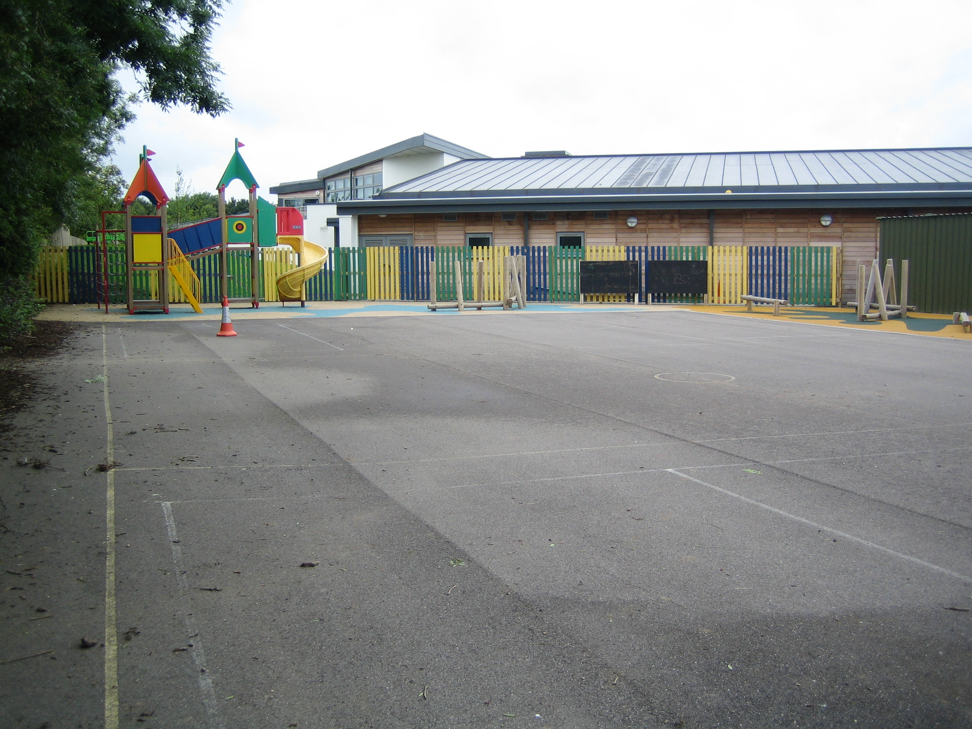
work playground child taxi/minibus noise
something else ……………………………………………………………………………………
What?
fight rip work run shout

something else …………………………………………………………………………………
How ?
1 – 10   
Count calm corridor speak to teacher

Another way ……………………………………………………………………………………….

Why?

……………………………………………………………………………………………………………….

……………………………………………………………………………………………………………….
What? angry

……………………………………………………………………………………………………………….

……………………………………………………………………………………………………………….
How? calm again
……………………………………………………………………………………………………………….

………………………………………………………………………………………………………………..

