Miss Chisholm©
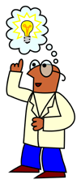
Our Invention Booklet
Identify a Need or Want
- What problems would you like to try to solve?
- ___________________
- ___________________
- ___________________
- ___________________
- Mark your chosen problem with an X.

- Who will benefit from your invention?
_____________________

10. My Invention!!
______________
Put a picture of your final design here:

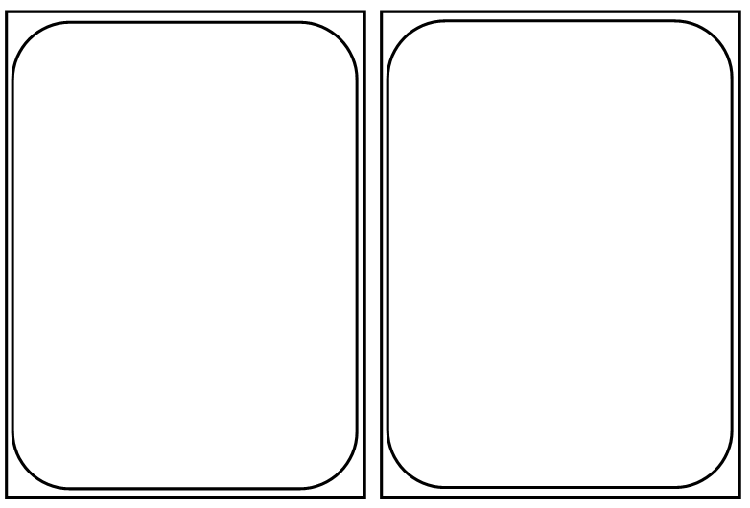
- Evaluate product and design process
- How effective is your invention at solving the original problem?
Mark out of 10 ______
- What changes would you make?
_________________________________ _________________________________
_________________________________

- How well did your team work together?
Mark out of 10 ______
- What could you do to improve your team work?
_________________________________
_________________________________

- Brainstorm Solutions

Problem

- Select a Solution
- Which was the best solution to your problem?
_____________________________
- Why?
____________________________________________________________________

- Present the invention for others
- Who will you present your invention to?
______________________________________________________________
- How will you do this?
_______________________________________________________________________________________________________________________________________________________________________________________________________________________________________________________________________________________
- Test the model
- How effective is your invention?
______________________
______________________
- How will you test your model?
______________________
______________________
Draw a diagram of your test below.

- Conduct Research
- What will you try to find out?
_______________________
- How will you do this?
_______________________
_______________________
_______________________
_______________________
_______________________
_______________________
_______________________ _______________________

- Develop a plan
- What will you need to do to design and create your invention?
To do list:

- Design a model
- What is your model made of?
___________________________
___________________________
- Draw a labelled diagram of your model below:

