Design and Technology

Designing and making a boat

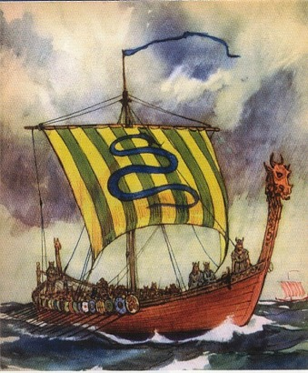
Name
Drawing different boats
Learning objectives:
- To know that boats are designed for different purposes.
- To evaluate boats and identify features that can be used for your own designs.
- To make labelled drawings showing specific features.

Making and testing boats
Learning objective:
- To investigate how different sized /shaped boats affect the amount of cargo they can carry.
Which holds the most?
PLASTICINE BOATS
Shapes

The __________ shaped boat held the most. I think this is because ____________________________________
____________________________________________
TIN FOIL BOATS
Boat size | 10 cm x  10 cm | 10 cm x  8 cm | 20 cm x  5 cm | 25 cm x  4 cm
Cargo

The _____________sized boat held the most. I think this is because ___________________________________
____________________________________________
Hulls and sails
Learning objectives:
- To investigate how the shape of a hull affects the speed it travels.
- To design and test different sails.
Do different hull or sail shapes affect the speed a boat travels? HULL SHAPES
Shape

Number of seconds

I found out ____________________________________
____________________________________________
SAIL SHAPES
Shape

Number of seconds

I found out ____________________________________

My sail design

_________________________________________________________________________________

My boat design
Learning objectives:
- To design a boat for a particular purpose.
- To draw up simple design specifications.
- To plan the stages of how to make the boat.
Materials and tools | Step by step plan
My boat design

Type of boat (purpose):

How it moves:
Boat evaluation
Learning objectives:
- To evaluate my boat identifying strengths and areas for development.
- To compare my finished product against the original specifications.

Does your finished boat look like your original design? (If no, why not?)
___________________________________________________________
___________________________________________________________
Does your boat meet the success criteria?
__________________________________________
__________________________________________
__________________________________________
__________________________________________
What are you most pleased with?
___________________________________________________________
___________________________________________________________
How could you improve your planning or your boat design?
___________________________________________________________
___________________________________________________________
___________________________________________________________
___________________________________________________________
What have you learned from this DT project?
___________________________________________________________
___________________________________________________________

