Year 6 Design and Technology

Design and make a type of bread
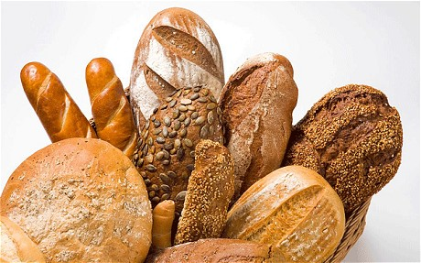
Name: ………………………………
What is the task?
Your task is to design and create a type of bread.

What do I know about this?
Create a mind map to record your prior knowledge about bread. (Think about: how bread is made, what different types of bread you know, where bread comes from, bread in religion, what bread is used for)

Bread

Market research
Before designing your own bread, you need to know what is already available and what bread is most popular. You don’t want to make bread that isn’t very popular. Why not be creative and mix ideas together! (Think about researching different: shapes, sizes, ingredients)

Product analysis – taste different types of bread products and complete the analysis grid.

BREAD | TEXTURE | APPEARANCE | FLAVOUR | RATING (out of 10)
White sliced
Wholemeal sliced bread
French stick
Bagels
Naan bread
Cheese bread

Bread survey
Create a survey to find out the most popular bread. This can be a survey done in class, in the school or at home. Remember you get a better picture of your survey from a wider range of people.
Record your findings and then present your results in the most effective way.

How many ideas can I think of?
Now it is your turn to design some bread products that you could make! Think about the research you have done. Remember your designs need measurements and a list of ingredients! You need at least 3 designs.

Which is the best idea?
You now need to decide which of your designs you are going to make.
Create a set of instructions to help you make your bread product. Use the SC to help you.
Level Four | - Imperative verbs  - Uses adverbs  - Prepositions  - Time connectives  - Chronological order  - Second/Third person if more than one person is involved.  - Subject specific vocabulary | - Title  - Sub headings  - Labelled illustration or diagrams to support specifics in the text.  - Bullet point or numbers. | Introduction  Title – How to…  A sentence about what is to be achieved.  List of ingredients and quantities under a sub heading.  Main body  Sentences to describe each step with specific information and detail  Conclusion  A sentence to say what the end product will be like and what it can be used for.
Level Five | - Imperative verbs  - Uses adverbs  - Prepositions  - Time connectives  - Adjectives  - Chronological order  - Second/Third person if more than one person is involved.  - Subject specific vocabulary  - Appropriate language for identified audience | - Title  - Sub headings  - Labelled illustration, diagrams and photographs to support specifics in the text.  - Bullet point or numbers. | Introduction  Title – How to…  A sentence about what is to be achieved.  List of ingredients and quantities under a sub heading.  Main body  Sentences to describe each step with specific information and detail (How, where, what, when)  Conclusion  A sentence to say what the end product will be like and what it can be used for.
Let’s do it!
Now it is time to make your bread product! Before you do please can you make a list of the health a safety rules you are going to follow. (Think about hygiene rules and any risks) Add any photographs of you making your product.

How well did I do?

What did I do well throughout the whole task? | What would I do differently if I was to do this task again?

What have I learned?

List some of the things you have learned from doing the task. This could be about bread, designing, health and safety, the science behind bread making or the group you worked with.

