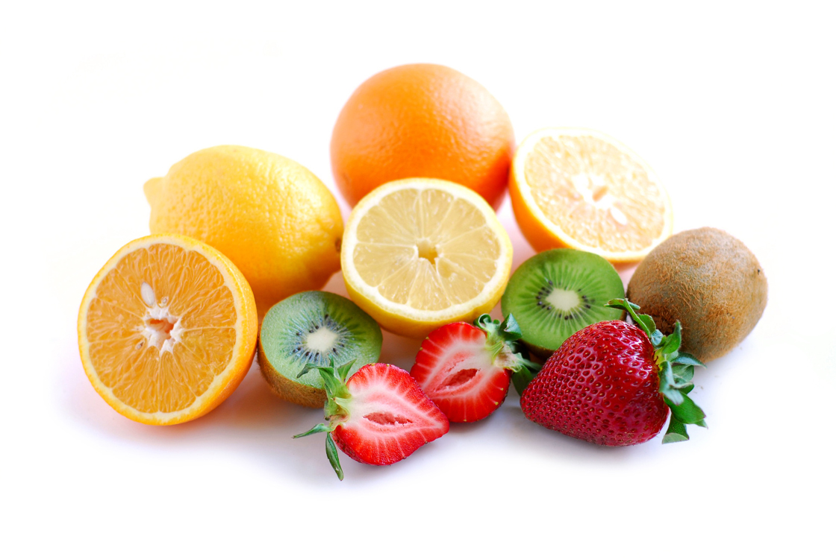
Designing a Fruit Salad
Name………………
List of fruit for my salad.
1_______________2.______________3.______________4.______________
Draw your fruit salad in the bowl.

What does your fruit salad taste, smell, and look like ? _________________________________________________________________________________________________________________________________________________________

Which 1 fruit would you like to add to make your salad even more delicious!

_________________________________________

Evaluation
How can we change our fruit salad to make it even better ?
What can you do to it OR add to it to change it ?

_________________________________________________________________________________________________________________________________________________________

