What Makes a Good Shelter?

Think about the following types of shelter:

Igloo Wendy-house Cardboard tunnel

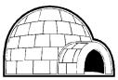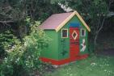

Wig-wam Tent Tree-House

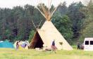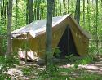

Detached House Sky Scraper Terraced House



Now have a think about the types of weather that each shelter is going to be facing.

Look at the following sheet overleaf, see how suitable the shelter is for each type of weather condition and place a tick or a cross in the column. Give reasons.

‘✗’ means not suitable for the type of weather  ‘✓’ means it IS suitable for that weather | Hot/sunny | Cold | Windy | Rainy | Snowy

