Pneumatic Systems
Pneumatic systems use _ _ _ to make things move.
When you compress or _ _ _ _ _ _ air out of a container like a _ _ _ _ _ _ it will push the air to fill another container like a balloon. The balloon will in_ _ _ _ _ _. If you release the pressure it will de_ _ _ _ _.
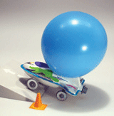
Pneumatic systems are used by many different objects. Can you name these and some of your own.
inflate, air, deflate, syringe, squeeze

