A.P.P. Assessment Focuses.
The five principles which underpin the effective teaching of Literacy;
- Use V.A.K. Balance the strategies used (muli-modal teaching increase retention).
- AVOID isolated drilling. You must discreetly teach the element (10 mins), then encourage use (apply).
- TURN levelled objectives into games.
- LINK work to pupils interests.
- STANDARDISE the language used throughout school. Must be the same in each classroom.
All of these activities can be adapted to cover pre level 1 – 5.

Simple sentence games.

Pictorially put sentences together.

I to the it was a day.

Simple sentence games.

Initial letter followed by ‘magic line’.

I l____ m___ h___.

I like my hat.

Simple sentence games.

Complete words – put them in order.
I like today .
your really dress

I really like your dress today.

Simple sentence games.

Sentence grids (A3 strip).
 |  |  |  | .
When? | who? | where? | what? | .
 |  |  |  | .

Any mixture e.g. Who? where? what?.

Simple sentence games.

Bare bottoms on a rugby post.
wwwww

h h h h h
e o e a y
n r t ow?
e

Simple phrases & clauses (AF5).

Noun phrase game.
Use object / picture, change each time.
A dog.
A brown dog.
A big dog.
A big, brown dog.

Simple phrases & clauses (AF5).

‘Where is it?’ game.
Use an object and describe where it is in as many different ways as possible. E.g. book
The book is ... in Phil’s hand.
under the ceiling.
next to Sophie.
on top of the table.

Simple phrases & clauses (AF5).
Character / place description.

Have pictures of characters and places (develops language and setting description).
green large scary bushy think
overgrown deep wild dark
Set a numeric target – I can think of 5 things to say about the image. Who can beat me?

Sentence structures – linking clauses (AF5).

Level 1 use ‘and’ extend as necessary.
 |  |  |  |  |  | .
When? | who? | where? | what? | and | what else? | .
 |  |  |  | and |  | .

Level 2 but / then Level 3 because / so Level 4 however / although Level 5 since / despite etc.

Sentence structures – linking clauses (AF5).
Physical sentence games.
Give children a word each, they need to put themselves in order.
dog The around the ran table

What could be added? . adjective ,
What could we change? WOW word (ran = zoomed)

Variation in sentence openers (AF5).
Circle game – open sentences in a variety of ways (list the ones you want them to use at the start).
Level 1 Demonstrative – This – That – These
Indefinite – Some – Many
Interrogative – Who – What – Which
Personal – Amy – He – They
Level 2 Time openings – One day – Yesterday – Later
Sequential – First – Then – Next – After
Action verb – Put – Take – Slice
Questions – Are you hungry?

Sentence structures – linking clauses (AF5).

BOYS sentences – Level 2.
.... but .... or .... yet .... so ....

FANBOYS sentences – Level 3

.... for .... after .... not .... but .... or .... yet .... so ....

Sentence structures – linking clauses (AF5).

2A sentences – Level 2 (2 adjectives before the noun).
It was a tall, silver alien.

4A sentences – Level 3 (2 adjectives before the 1st noun, 2 adjectives before the 2nd noun).
It was a tall, silver alien wearing a sparkly, shiny helmet.

Past & Present tense (AF5, L2).

‘ing’ and ‘ed’ game - to be played as a ‘warm up’ only.
The teacher is marking the book.

The teacher marked the book.

Discuss changes to sentence, highlight endings of the verb.

Sentence structures – linking clauses (AF5, L3).

Complex sentences (because, after, since, although).
Play with oral and written sentences and extend them using the listed connectives. Discuss meaning and how connective influences the ending of the sentence.

The pupils are playing because it is playtime. (explains)

Common connectives (AF5, L3).

Physical reminders – use your body actions.

A B S


n u o
d t

Variation of tense & verb forms (AF5, L3).

... like a ... / ... as a ... sentences (simile focus).
(when?) The wind was as cold as ice. (where?)

On a stormy evening -
- the wind was as cold as ice -
- as I sailed across the Atlantic ocean.

Vocabulary (AF5).
www.visualthesaurus.com (mind maps alternative words for child to focus on).
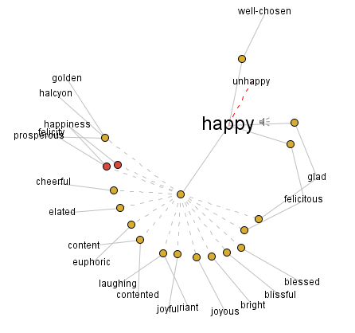

Variation in length, structure or subject (AF5, L4).
3 ‘ed’ sentences (3x related emotions).
Frightened, terrified, exhausted, they ran from the creature.

Can extend to include a flashback of events;
Frightened, terrified, exhausted, they ran from the creature . . . A week ago the space ship hadn’t landed.

Variation in length, structure or subject (AF5, L4).

If, if, if sentences.
If the alarm had gone off, if the bus had been on time, if the road repairs had been completed, then his life would not have been destroyed.

Teach backwards from outcome.

Variation in length, structure or subject (AF5, L4).

Noun - which,
- who,
- where, sentences.
Cakes, which taste fantastic, are not so good for you.

Ben, who is always late, was actually on time today.

Asda, where I first met Sam, is such a lovely place.

Variation in length, structure or subject (AF5, L4).

Short sentences for tension.

Then it happened. Everything failed. It went dark.
(follow with a lengthy piece
of description).

Subordinate clauses (AF5, L4).
Handy connectives.
on the other hand
however although nevertheless despite so/since
thumb – therefore middle finger – moreover little finger - likewise

Variation in tense & verb forms (AF5, L5).
Verb, person sentences – ‘-ing’ word comma.

Flying, John had always been terrified.

Emotion, sentences – ‘emotion’ word comma.

Happily, they walked towards the kind lady.

Variety of sentence lengths, structure & subject (AF5, L5).

De:de sentences – description: detail (wwwww).

The vampire is a dreadful creature: it kills by sucking blood.
it lives in Transylvania.

Variety of sentence lengths, structure & subject (AF5, L5).

Imagine opener – 3 examples.

Imagine a time when people were not afraid (1), when life was much simpler (2), when everyone helped each other (3); this is a story about that time.

Variety of sentence lengths, structure & subject (AF5, L5).

O. (I.) sentences. (outside / inside)

He smiled and shook the man’s hand warmly (inside, however, he was more terrified than ever).

Variety of sentence lengths, structure & subject (AF5, L5).

Double ly ending sentences – verb followed by two adverbs.
He swam slowly and falteringly.

‘ing’, ‘ed’ sentences.
Walking in the bush, she stopped at the sight of a crocodile.

Wider range of connectives (AF5, L5).
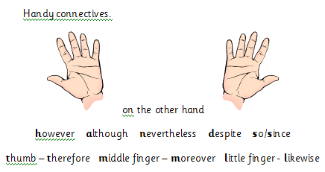 add onto this ‘FEET’
further more
equally
eventually
this means that



AF5

