Simple accuracy & punctuation.

‘Talk aloud’ technique - as you are modelling on the board, talk aloud (raises awareness) –

“I’d better remember my full stop at the end of a sentence.”

Simple accuracy & punctuation.

Noun and verb phrase games (oracy based). Use images.

T write: A ________ house.
T ask: Is it big or small?
P: big.
T & P read together: A big house. EXTEND for higher levels.



Accurate clauses (AF6, L1).
Verbal / written clause grids – use visual cards
Who? | what? | where? | .
 |  |  | .
Photos of children, familiar jobs etc. | Photos of running, walking, swimming etc. | Photos of location / places etc.



Awareness of full stops & capitals (AF6, L1).
Two/three sentence making grids (W words & full stops in different places).
 | was | ☺😐☹ |  | he/  she |  | . |  | was
Who? | was | feeling? | so |  | what? | . | Who? | was
 | was |  | so |  |  | . |  | was

☺😐☹ |  | he/  she |  | .
feeling? | so |  | what? | .
 |  |  |  | .

Punctuation face (AF6).
A4 laminated face with different punctuation colour coded for each table to focus on. At the end of the writing, children to colour code evidence that they have used it.

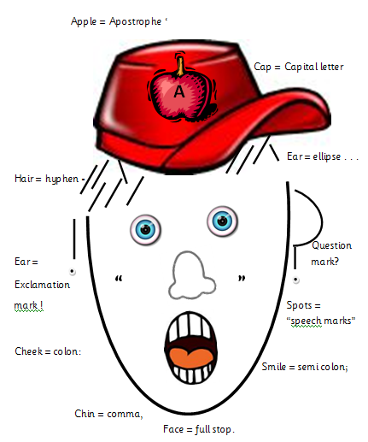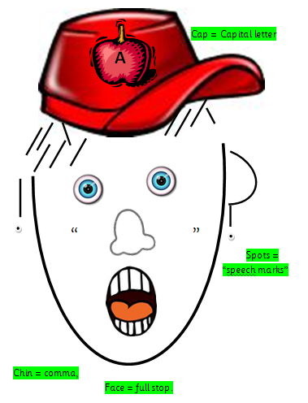
“I have been looking for you,” said Bill. He had spent 3 days searching high and low.

Comma use (AF6).

- Instead of ‘and’ list sentences – The princess is pretty, tall and very intelligent.

- Instead of ‘or’ in a list – Today we could go to the park, visit the zoo or have a picnic.

Exclamation use (AF6).

- Interjections – shouted or said loudly.
- Echo – ‘We finish at 7pm’ replied the teacher. ‘7pm!’ said the student.
- Commands – Don’t! – Now!
- Onomatopoeia – Boom! – Pow!
- What + and adjective and noun – What beautiful weather!

Sentences punctuated correctly (AF6, L3).
- Expanding range of question stems.
Did? Can? Should? Will?
Is it? Are they? Would you?
(wwwww)
- The ‘surely’ sentence opener rule.
Surely ......... ?

Speech punctuation (AF6, L3).

- Comic transfer approach.
- 66/99 new speaker new line.
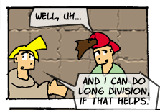

Bill said “and I can do long division if that helps.” Ted looked confused and replied “well, uh...”

Sentence demarcated accurately (AF6, L4).

Questions for answers (like we do in numeracy).

Answers are; a. Pyramid
b. Nile
c. mummies
What was the question?

Sentence demarcated accurately (AF6, L4).

Bracketed question marks for uncertainty.

In 1966 (?) I went to ....

(?) shows that the writer is not completely sure of the date.

Speech marks / punctuation (AF6, L4).

- Comma and direct speech - always use a comma if speech verb comes before the speech.
John shouted, “thanks guys!”

- Punctuation in a sentence (using direct speech) split by a speech verb.
“I love,” he exclaimed, “everything about this place!”

Commas (AF6, L4).

Sandwich sentences – clause is embedded (can take it out).

That morning, which would be his last, the sun rose in a cloudless sky.

That morning the sun rose in a cloudless sky.

Full range of punctuation (AF6, L5).

Semi colon teaching – phrase list

It was cold, damp and wet EXPAND
It was a cold winter night; damp and dreary; wetter than it had been.

Full range of punctuation (AF6, L5).

Colon (De: de) sentences – description: detail (wwwww).
The vampire is a dreadful creature: it kills by sucking blood.
it lives in Transylvania.
‘being’ swap
There are 3 types of fruit I like: apples, bananas and pears.

Full range of punctuation (AF6, L5).
Brackets
- Extra detail – Long ago (when I was about 12)... (wwwww)
- Authorial intrusion – author interrupts or comments on text.
- A list which interrupts – The 3 nicest flavours (chocolate, strawberry and mint) are...
- DOB / dates / death etc.
- Latin name used after common name.

Full range of punctuation (AF6, L5).

Guided reading / reading task – as children read they need to collect examples and explain.
Mark | Name | Example (from text) | Reason for use
! | Exclamation mark | Wow! Look at that. | To show surprise.
?
“”

AF6

