Simple vocabulary games.

Across word – children can work on own or in pairs. Need to think of biggest word to fit in the gap. Score 1 point for each additional letter added.
a ntelop e 6
t s
w t
b d

Simple effective vocabulary.
Boxing clever – label boxes / bags with the headings;
Who? Where? Where next? Why? Where last?
Fill boxes / bags with a wide range of images. Use these to re-tell / write a story. Teaching beginning, middle and end is useless, children need to see what happens in each section.

Simple effective vocabulary.
HFW sight recognition boxes to support children in seeing the shapes of the word. This website has lots of HFW worksheets (word tiles) to print or do on screen: http://rbeaudoin333.homestead.com/sightvocab_1.html#anchor_381
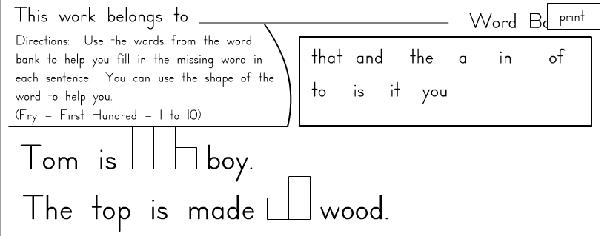

Simple vocabulary (AF7, L1).
Expand vocabulary through Action Rhymes; sing up, www.preschoolrainbow.org or search for (rhymes) (fingerplays).

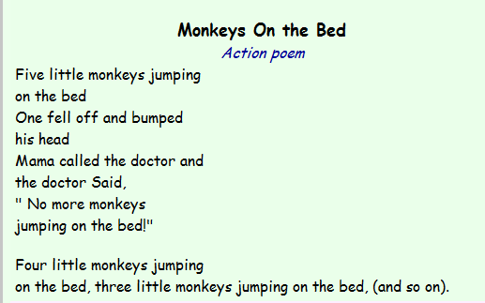

Simple vocabulary (AF7, L1).

Sight recognition games – the minimum 5 key areas that children should know in Y1: use word tiles at http://rbeaudoin333.homestead.com/sightvocab_1.html#anchor_381
- Days of the week.
- Months of the year.
- Numbers to 20.
- Common colour words.
- Name and address of child and school.

Simple vocabulary (AF7, L1).
Expand vocabulary with animated on-line stories.
www.animatedstories.com or www.anithings.com
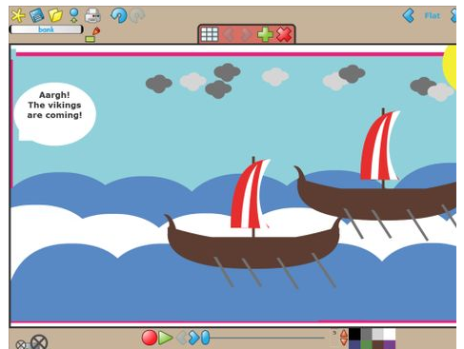

Communicates meaning (AF7, L1).
Hendecasyllabic game (11 syllables). Numeracy minded children will love this activity. Start with a child’s favourite food, toy, hobby etc. Count the syllables in each sentences and extend until you have used 11 syllables.
I like lego. 4
I really like lego. 6
I really like playing with lego. 9
I really like playing with lots of lego. 11

Communicates meaning (AF7, L1).

List poems – children to create a simple list / word poem about themselves, nature, school etc.

green
tall
leafy

blossom
breezy
wood

Speech like vocabulary (AF7, L2).
Genre related vocabulary (food & drink, adjectives, magnets &
springs, Romans etc.) – staircase of linking words (must be
able to give meaning of the word to use it.

B e a u t i f u l She was a _____ princess.
a
z Extend by banning the obvious/
y o u n g creating the unexpected/
i linking last 2 letters (thinking
a ahead)
n
t a l l

Some adventurous word choices (AF7, L2).
Colour highlighting – enter a child’s work into www.wordle.net
It displays the words used, the larger the word the more it was overused. This word can then be highlighted throughout the text and entered into the www.visualthesaurus.com print of the mind map and encourage child to use it next lesson.
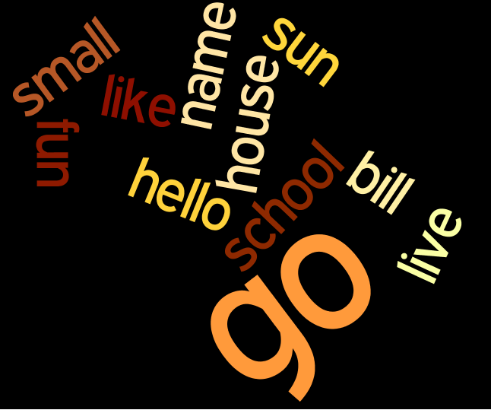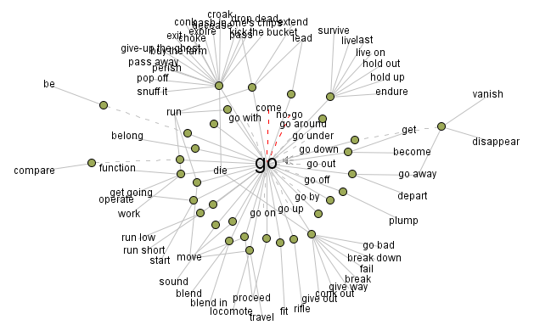

Speech like vocabulary (AF7, L2).

Extended staircase example (any theme / genre) –
Last 2 / first 2 (food & drink example).
Lasagne
nettle soup
upside down cake
kettle

Words selected for effect / occasion & Generally appropriate vocabulary (AF7, L3).
Genre related phrase banks - To be done with any genre at the start of the topic for assessment and the end for assessment - teach to the gaps. E.g. Fairy tale
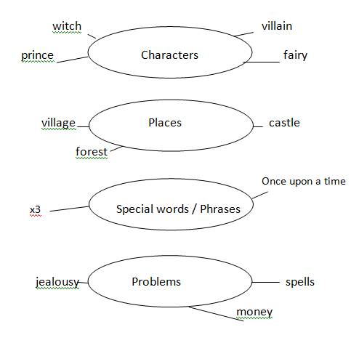

Children know about the characters who are likely to appear in a fairy tale. They understand the main places and problems that could happen. Although they know that events and happenings are likely to happen in 3s, they do not recognise the need for repetition in phrases and the suitable ways to end a fairy tale.

Words selected for effect / occasion & Generally appropriate vocabulary (AF7, L3).
Word of the week – www.allwords.com
Display in class: put into www.visualthesaurus.com , use in your writing, add your own contextualised sentences around it, look at definition, different language etc.
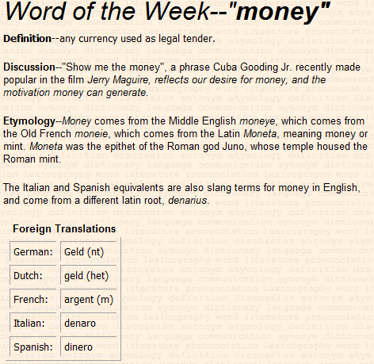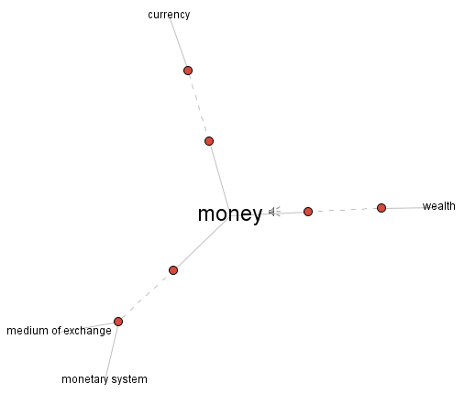

Words selected for effect / occasion & Generally appropriate vocabulary (AF7, L3).

Glidograms (thematic – use a, e, i, o, u).
a _____ a _____
_ a _____ _ a _____
_ _ a _____ _ _ a _____
_ a _____ _ a _____
a _____ a _____

n t
b d g e r
s n k e

c t
ardvark

Deliberate vocabulary choices (AF7, L4).
Use www.visuwords.com
Allows you to explore synonyms and defines words. Branches can be expanded to develop the word / meaning further.
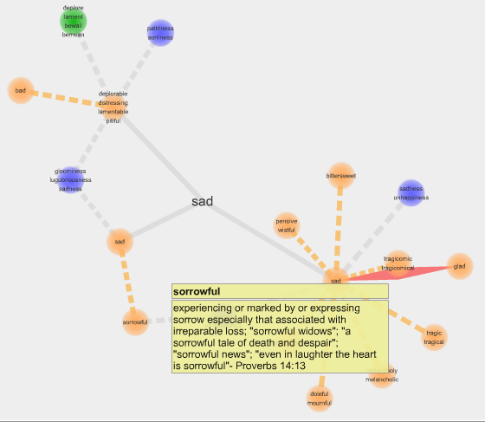

Deliberate vocabulary choices (AF7, L4).
Lipograms – ban a letter on the alphabet. Challenge the children to edit a sentence or re-tell a story, really gets them to think about language and word choices “constraints helps you to learn”.
(e.g. ban ‘o’)
astride mares
Humpty Dumpty sat on the wall, all the kings’ horses and all the kings men

Extend – monosyllabic, last word of each sentence rhymes etc.
Further ideas in Alan Peats book: 50 ways to retell a story.

AF7

