
Purpose:
To give an account of someone’s life

Structure:
- Opening statement introduces the subject, and explains why he/she is known
- Significant events are ordered chronologically
- Closing statement explains how this person will be remembered, and sometimes gives the writer’s opinion

Language Features:
- Refers to named individuals
- Contains dates linked to specific events
- Written in the past tense
- Can include direct and indirect speech and quotes from other sources
- Written in 3rd person
- Includes time connectives to link ideas
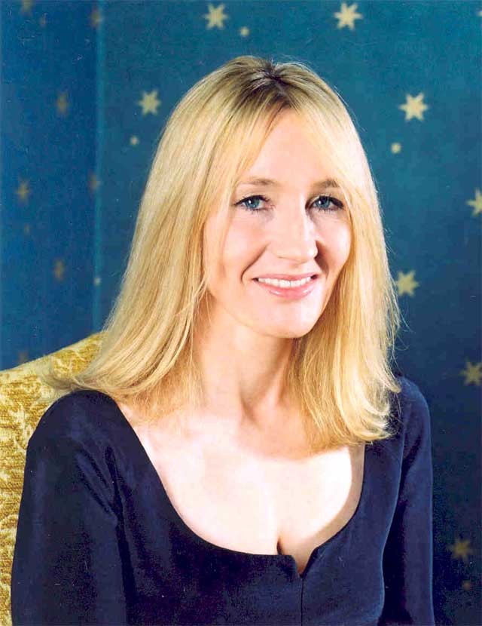

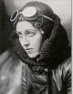


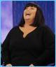
- Events are anecdotal in style (rather than lists of facts), and engage the reader

