Homophones are words that sound the same but have different spelling and meaning.

our  Our baby. | hour  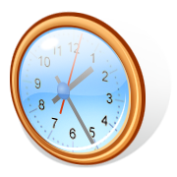  I played for an hour.
write  I write with a pencil.  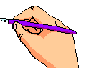 | 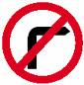  right  Do not turn on the right.
buy  I buy food from a supermarket. | by  I go to school by bus.
break  I play hop-scotch during lunch break.  four  Four cats. | brake  Press the brake to stop the car!  for  This is for you.
night  We sleep during the night. | knight  He is a knight.
here  “Come here!” said the cat. | hear  I hear a noise.
where  “Where is the treasure?” said Bob. | 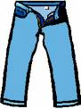  wear  I like to wear jeans.
Sea  The turtle lives in the sea. | See  I can see better with my glasses.

