Name Rotten Apples

Draw and write the main events of the story.
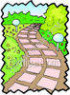The story starts in the garden.

The story ends in the car park. 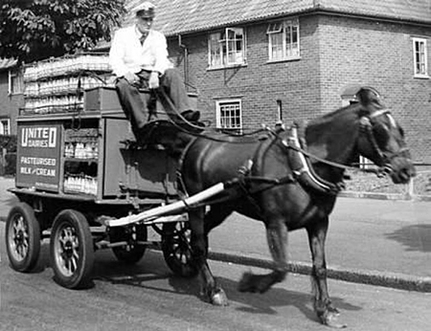

Name Rotten Apples

Read through the story and find words that have the same sound but different spellings from the ones below.

Write the words you find.

sum | maid | buy | sea | sore | no

Find the other words that sound the same but are spelt differently match them and write them in the chart.

there | their
Knight | Night
Break | Brake
Key | Quay
Right | Write
Son | Sun
Sale | Sail

