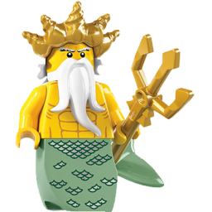
Fantasy World Stage 6

The Magic Trident

- Underline the correct ending for each sentence.

1. The king of the sea lived
- under the sea
- in a cave
- in a magic trick

2. The king blew on his trident and made the fish
- blue and green
- red and blue
- red and green

3. When Nipper blew on the trident the fish
- had a red scarf on
- had blue socks on
- had a green hat on

4. When Big Mouth and the fish had hats on they were
- happy and laughing
- cross with Nipper
- wanting a hat too

- Rhyming words

Page | Find a word that rhymes with | Word in book
3 | me
5 | would
6 | sing
9 | cooked
11 | dish
12 | boss
15 | new

- Read and draw
Nipper swam off with the trident and when he blew on it the fish got a hat.
The fish looked at Big Mouth with his hat on and the King was cross with Nipper.

