Story Writing

Sometimes, starting a story is difficult and you don’t know where to begin. It is often helpful to sit and think of interesting sentences about parts of your story then put them together for your tale.

We are going to write a story about mountains and mountain climbing.

Task: Look at the pictures and think of 3 interesting sentences about each one.

Think about The size, height and shape of mountains. What colours does the mountain make you think of?

1. 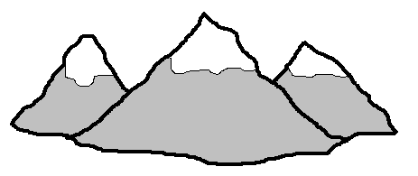

………………………………………………………………………………………………………………………

………………………………………………………………………………………………………………………

………………………………………………………………………………………………………………………

………………………………………………………………………………………………………………………
Think about the kind of weather you get on mountains.

2. 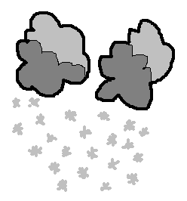 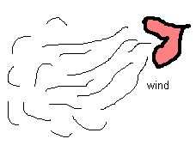

………………………………………………………………………………………………………………………

………………………………………………………………………………………………………………………

………………………………………………………………………………………………………………………

………………………………………………………………………………………………………………………

………………………………………………………………………………………………………………………

If you were climbing a mountain think about the kind of clothes you would have to wear and the equipment you might use.

3. 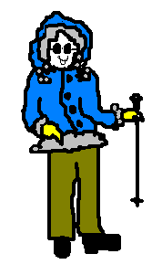 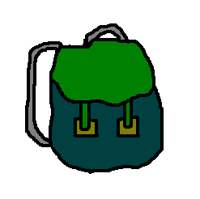 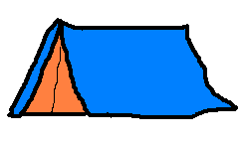
………………………………………………………………………………………………………………
3. Continued.

………………………………………………………………………………………………………………………

………………………………………………………………………………………………………………………

………………………………………………………………………………………………………………………

………………………………………………………………………………………………………………………

………………………………………………………………………………………………………………………

What types of danger might you face if you were on a mountain climb?

4. …………………………………………………………………………………………………………………

………………………………………………………………………………………………………………………

………………………………………………………………………………………………………………………

………………………………………………………………………………………………………………………

………………………………………………………………………………………………………………………

………………………………………………………………………………………………………………………

………………………………………………………………………………………………………………………

………………………………………………………………………………………………………………………

What kind of animals and plants might you see? What types of things won’t you see?

5. 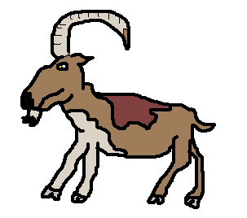 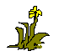

………………………………………………………………………………………………………………………

………………………………………………………………………………………………………………………

………………………………………………………………………………………………………………………

………………………………………………………………………………………………………………………

………………………………………………………………………………………………………………………

You have completed your climb and are at the top of the mountain, how do you feel? Are you tired, excited, relieved and happy? Would you do it again?

6. 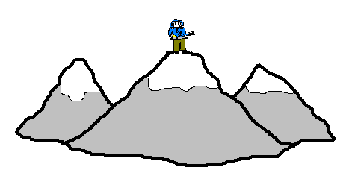

………………………………………………………………………………………………………………………

6. Continued.

………………………………………………………………………………………………………………………

………………………………………………………………………………………………………………………

………………………………………………………………………………………………………………………

………………………………………………………………………………………………………………………

………………………………………………………………………………………………………………………

………………………………………………………………………………………………………………………

………………………………………………………………………………………………………………………

