Words for describing what things look like
To look
- observe
- peek
- peer
- scan
- scrutinise
- spy
- squint
- stare
- view
- watch
Dull
- colourless
- drab
- faded
- pale

Dirty
- filthy
- grimy
- grubby
- stained
- tarnished
- unclean

Sparkling
- flickering
- glimmering
- glinting
- glittering
- glistening
- shimmering
- twinkling
Smudged
- blurred
- smeared

Bright
- blazing
- brilliant
- dazzling
- glaring
- gleaming
- glowing
- light
- radiant
hair
- blond
- brunette
- auburn
- bleached

Dark
- dim
- dingy
- dull
- gloomy
- murky

Clear
- crystal clear
- transparent
- see through
- invisible

Misty
- foggy
- cloudy
- hazy

Shiny
- glistening
- glossy
- polished
- reflecting
- sheen

Speckled
- dappled
- freckled
- mottled
- splotched

Coloured
- tinted
- tinged
- dyed

Ugly
- unattractive
- hideous
- repulsive
Worn
- faded
- ragged
- torn
- frayed
- Shabby
- tattered
Beautiful
- attractive
- pretty
- stunning
- gorgeous

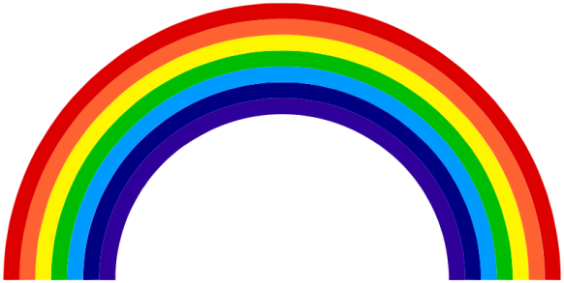
Words for colours

Blue
- azure
- cyan
- navy
- sapphire
- sky blue
- royal blue
- teal
- turquoise
- ultramarine
Yellow
- gold
- amber
- saffron
- lemon
- buttercup
- mustard
Black
- charcoal
- coal black
- ebony
- jet black
- soot
Green
- emerald
- jade
- lime
- turquoise
- apple green
- aquamarine
- olive
- khaki
Red
- burgundy
- cherry
- crimson
- maroon
- rose
- ruby
- scarlet
Purple
- violet
- mauve
- amethyst
- lavender
- magenta
Orange
- tangerine
- auburn
- coral
- peach
- apricot

Words for describing what things feel like

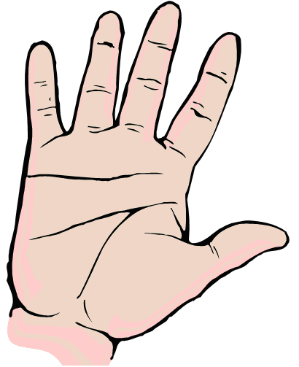
Wet
- damp
- drenched
- dripping
- moist
- soaked
- Soggy
Sharp
- prickly
- thorny
- barbed
- jagged
- pointed
- razor
- serrated
- splintered

Dry
- arid
- desiccated
- crisp
- parched

Hot
- warm
- baking
- blazing
- blistering
- boiling
- burning
- fiery
- flaming
- parching
- piping
- sizzling
- steaming
- scorching
- sweltering
- searing
Cold
- freezing
- bitter
- chilly
- cool
- frosty
- frozen
- icy

Rough
- bumpy
- bristly
- coarse
- lumpy
- gnarled
- textured
Soft
- comfy
- downy
- feathery
- fluffy
- furry
- spongy
- springy
- squashy

Smooth
- flat
- silky
- velvety
- glassy
- polished
Slippery
- oily
- greasy
- slimy
Hard
- firm
- solid
- tough
- stiff
- rigid
- strong

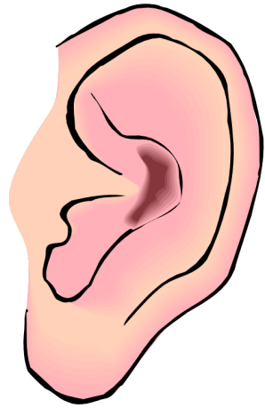
Words for describing sounds

Shout
- bellow
- boom
- cheer
Bang
- blast
- clang
- clank
- crash
- crunch
- knock
- pop
- slam
- thud
- thump

Other sounds
- clink – of a glass
- crackle
- creak – a door
- echo
- fizz
- grunt
- gurgle - liquid
- honk - a horn
- hush – quiet
- jangle - keys
- jingle
patter - rain
- plunk
- racket
- rasp
- rattle
- ripple
- rumble
- rustle
- sizzle
- smack
- snarl
- snort
- splash
- swish
- tap
- toot

Scream
- screech
- shriek

Animals
- bark - dog
- buzz - bees
- cheep - bird
- chirp - bird
- croak – frog
- drone - bees
- growl - dog
- hiss - snake
- hoot - owl
- howl - dog
- meow - cat
- moo - cow
- purr - cat
- quack - duck
- roar – lion
Moan
- groan
- grumble
- rant

Talk quietly
- mumble
- murmur
- mutter

Sing
- chant
- hum

Laugh
- chuckle
- chortle
- giggle

Cry
- bawl
- blubber
- squeal
- wail

Talk
- chatter
- hubbub

Words for describing smells
Nouns

- aroma
- fragrance
- odour
- perfume
- reek
- scent
- stench
- stink
- whiff

Adjectives

- musty
- pungent
- putrid
- rancid
- rank
- spicy

Words for describing how things taste
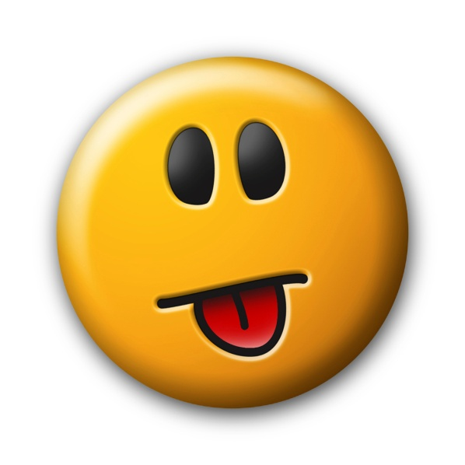
- acidic
- appetising
- bitter
- bland
- delicious
- flavoursome
- gingery
- honey
- insipid
- mellow
- peppery
- salty
- sharp
- sour
- spicy
- sugary
- sweet
- tangy
- tasteless

