My parents gave me a lightning fast bike. It had rubber burning tyres on its wheels and a shiny frame. There were gears that help me to go fast like a jet and a brand new sparkly bell that shines in the sunlight. There were tyres on the wheels and there was a comfortable saddle made from luxury leather.

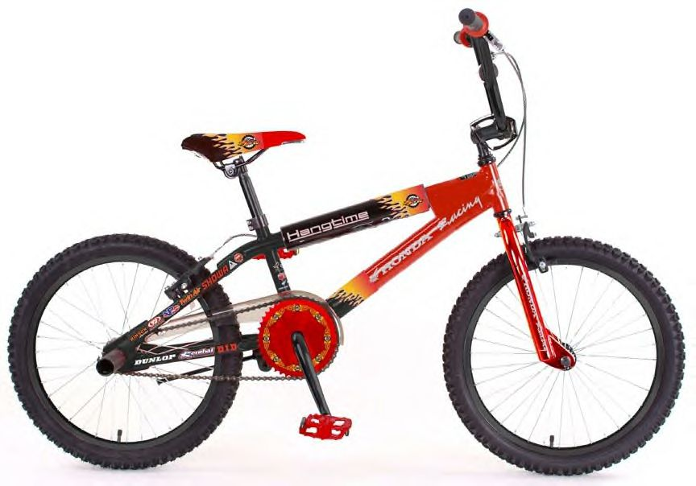

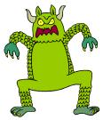

The gigantic, terrifying, ugly monster stomping from his cave towards me like a flesh eating dinosaur with its blood dripping jaws open and its boiling breath smelling of rotten eggs.

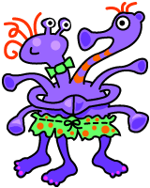

Matilda
She has nine shiny pink painted toenails, on her big hairy feet. She is violet and giant, she has three smelly hairy feet
Bright purple
Best imaginary friend
Six wobbly long arms
Lovely friendly
Mumbles quietly
Spotty, purple, cute, friendly
Sweet, purple headed
Shiny orange spotted skirt
Funny curly electric hair

