Name: ……………………………………… ………………………………………………………

Traditional stories: Aladdin

……………………………………………………………………………………………………………………………………………………………………………………………………………………………………………………………………………………………………………………………

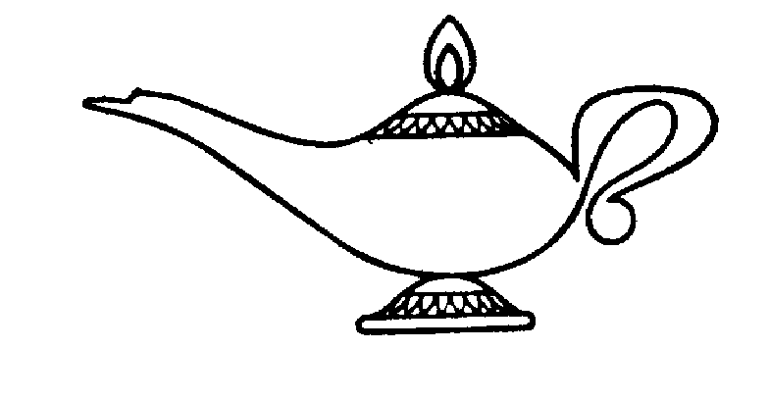

……………………………………………………………………………………………………………………………………………………………………………………………………………………………………………………………………………………………………………………………

……………………………………………………………………………………………………………………………………………………………………………………………………………………………………………………………………………………………………………………………

Name: ………………………………………………………

Traditional stories: Aladdin

Write down what you would wish for if you found a magic lamp, and why. Don’t forget that you’ve got three wishes!

……………………………………………………………………………………………………………………………………………………………………………………………………………………………………………………………………………………………………………………………

……………………………………………………………………………………………………………………………………………………………………………………………………………………………………………………………………………………………………………………………

……………………………………………………………………………………………………………………………………………………………………………………………………………………………………………………………………………………………………………………………

