a | b | c | d | e
f | g | h | i | j
k | l | m | n | o
p | q | r | s | t
Ants and an apple. | Bat and ball. |   Cute cat. | Dippy dog. | Enormous elephant.
Four flowers. | Garden gate. |   Haunted house. | 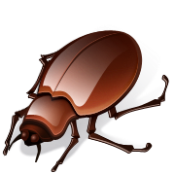  Insect in an igloo. | Jar of jam.
Kicking kangaroo. | Lazy lion. |   Mouse on the moon. | Nine nets. | Orange octopus.
Pirate with a parrot. | Quiet queen. | Red rabbit. | Slippery snake. | Train by a tree.
u | v | w | x | y
z | ch | sh | th | wh
qu | ng | nk | ck | ff
ll | ss | zz | gg
Under an umbrella. | Visit the vet. | 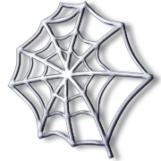  Worm in a web. | Fox in a box. | Yawning yak.
Zebra with zig-zags. | Chips and chocolate! | Shell shapes. | Thick thumb. | White wheel.
Quiet queen. |   A singing king. | Links in a sink. | Black duck. | 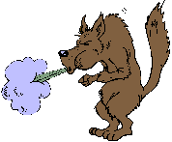  Huff and Puff.
Mill on a hill. | A messy dress. | Buzz, buzz. | Egg in an egg cup.

These cards do not print double sided, but are designed to fit back to back on small flashcards.

