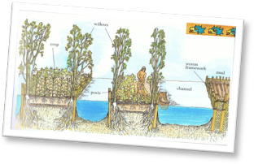

The Best Instructions ever!
How to make

Equipment you will need
If you’re going to make a garden, you better do it right. Get hold of all of the following equipment first so you are ready to get dirty!
- Fresh earthy soil or compost
- Small sticks of varying sizes and thicknesses
- A solid plastic tray with high sides
- A selection of mini gardening forks, trowels and sieves
- Clean tap water
- Bag of in-date cress seeds
- Camera (if you decide to film or photograph your progress)
Do you have all that? Great. Now you’re ready to really get green-fingered with the Aztecs.

What you will need to do
1. Use the trowel to carefully dig enough soil to fill the plastic tray but first sieve it with the smallest sieve (this will give you the finest quality of soil).
2. Scoop out two channels of soil so that you have three long strips of soil gaps in between each one (see picture above).
3. Collect a wide selection of sticks, which you then fix into the mud and along the edge of the banks so they hold the soil in place when the water is added later on. These represent the weaving and willows that the Aztecs would have used centuries before to prevent their crops from being washed away!
4. After this, evenly sprinkle the cress seeds onto the soil banks before carefully pouring water over the banks and filling the channels in between. These are the water channels the Aztecs would have travelled on in their boats to access their farmland.
5. Now your garden is complete, look after it by putting in a sunny and warm location and don’t forget to water regularly.
an Aztec Garden
By the way…
Aztec ‘floating gardens’ were called Chinampas, but did not float at all. They simply looked that way because of the water all around them.

