In literacy, we are learning about the difference between biographies and autobiographies. This week for homework, you need to choose a celebrity and create a fact file about their life. You can decide on your own categories. These might include name, age, place of birth, career details, special achievements, awards received etc. You may wish to sketch or print out a picture of your celebrity to accompany your work.
The start of an example is below...
NAME: Tulisa Contostavlos
AGE: 23
Date of Birth: 13th July 1988
Occupation: Singer/Songwriter and X Factor Judge.
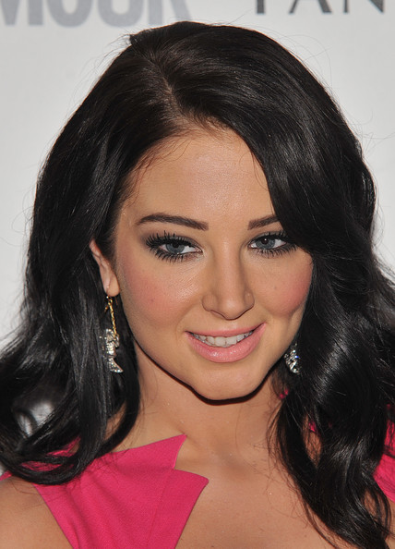

Try to think of a variety of additional fact file categories you could include about your chosen celebrity.

In literacy, we are learning about the difference between biographies and autobiographies. This week for homework, you need to choose a celebrity and create a fact file about their life. You can decide on your own categories. These might include name, age, place of birth, career details, special achievements, awards received etc. You may wish to sketch or print out a picture of your celebrity to accompany your work.
The start of an example is below......
NAME: Tulisa Contostavlos
AGE: 23
Date of Birth: 13th July 1988
Occupation: Singer/Songwriter and X Factor Judge.

Try to think of a variety of additional fact file categories you could include about your chosen celebrity.

