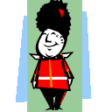

Idiom | We think this means…
A little bird told me
Back to square one
Cash cow
Deep pockets but short arms
Elbow grease
Fools rush in where angels fear to tread (walk)
Game on!
Here today, gone tomorrow
Just what the doctor ordered
Knight in shining armour

House: Year Group:
Idiom | We think this means…
Light at the end of the tunnel
Make a pig’s ear of things
Not my cup of tea
On the tip of your tongue
Pull up your socks
Raining cats and dogs
Sit on the fence
Watch paint dry
You can’t unring a bell
Zip it!

English Idioms

Exactly what you need | 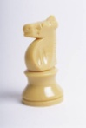  A friend who helps you | Something you do not like | People who do things without thinking
Hope for the future.   | 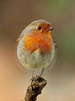  If someone doesn’t want to say where information came from | 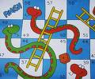  Whatever you’re doing, you need to start again | Something you can nearly, but not quite, remember
Make a mess. | Accept a challenge | A person who is wealthy but  does not share | Something that is very boring or dull
  A product or business that makes lots of money. | Some things do not lost very long | Something that will be hard work and needs lots of effort | Something you have done that cannot be changed
Try harder! | Really raining  heavily | Not taking sides in an argument |   Be quiet please!

