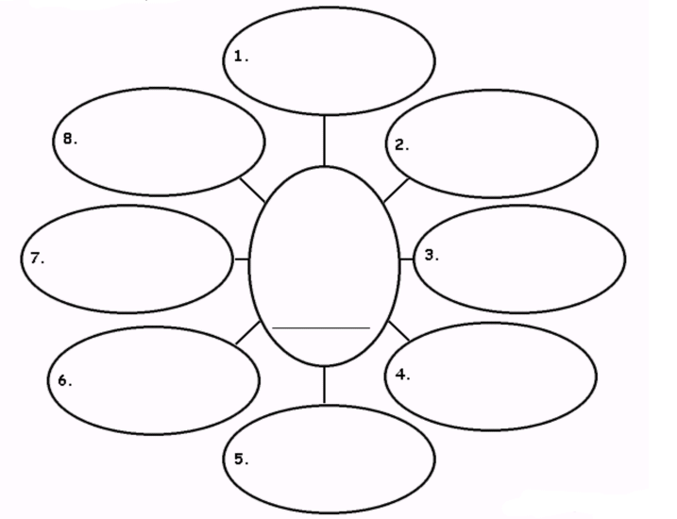
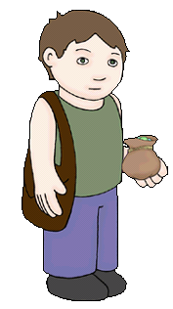
Can you use appealing adjectives to describe the Jack? (From Jack and the Beanstalk)
Adjectives
Can you put your adjectives into full sentences?

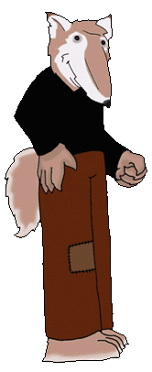
Can you use appealing adjectives to describe the Wolf? (From the Little Red Riding Hood)
Adjectives
Can you put your adjectives into full sentences?

