 | knight |  | 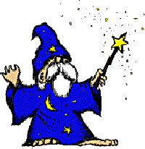 | wizard
 | dragon |  | 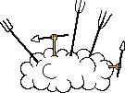 | fight
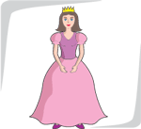 | princess |  |  | treasure
 | forest |  |  | gold
 | castle |  |  | mountain
 | fire |  |  | horse
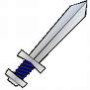 | sword |  | 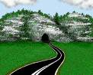 | cave
 | king |  |  | scared
 | happy |  |  | sad

