Floppy’s Phonics (2A) The Red Coat
Word List

Read the words to your teacher.

red | coat | king | Chip
said | bed | load | put
sing | will | soak | hip
shop | goat | dip | fed
tip | nip | wing | smell
bit | led | load | sip
pip | big | rip | odd
zip | soap | ring | foam
washing | look | upset | fits

Well done!!!

Tricky words

king ________________ _________________ ________________

coat ________________ _________________ ________________

smells ________________ _________________ ________________

odd ________________ _________________ ________________

foam ________________ _________________ ________________

soak ________________ _________________ ________________

load ________________ _________________ ________________

look ________________ _________________ ________________

When you have read the words three times to your teacher you can colour in the box.

king
coat
smells
odd
foam
soak
load
look

Sounds to think about:

oa

Say and write the words;

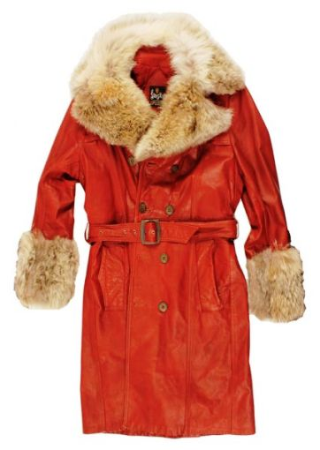

coat ______ ______ ______

soap ______ ______ ______

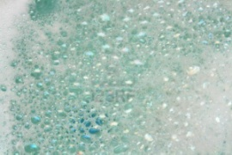 foam ______ ______ ______

goat ______ ______ ______

 boat ______ ______ ______

Pages 1-5

Look at the pictures.

What is Chip? Chip is a ________.

What does he need? He needs a ______ ________.

Where did they go? Mum took Chip to a _______.

What did Chip put on? Chip put on a ____ _____.

Draw the picture of Chip on page 5.

Pages 4-7
Put the story in order.

The coat had an odd smell.

Mum took Chip to a shop.

“Yuk. It smells odd,” said Chip.

Chip put on the red coat.

Who said it?

A red coat.
Page 3

_________________
Will this coat do?
Page 4

____________________
Page 10
I’ll put this load on.

____________________

Page 16 “He is the red king,” said ___________

Choose the correct word.

Page 9 It can ______ in the tub. soak / soap

Page 11 Chip put the ________ in. boat / coat

Page 12 Dad’s washing was ________ yellow / red

Page 14 Chip was _______ upstairs / upset

Pages 6 and 7
It _____ .

Draw the picture and label it.

Mum Chip Kipper Biff Wilf Wilma Floppy

Pages 8 and 9

Unscramble the sentences.

put Chip coat the tub. in the

soak the tub. It can in

What foam. of lot a

What did Chip say? What did Wilma say?

Pages 11 – 15

“But look at the coat,” said Mum.

Dad’s washing was red.

Chip put the coat in.

“Look at my washing,” said Dad.

Look at pictures. Who was it?

Yes or No?

Chip was a king. ________

Mum took Biff to a shop. ________

Wilma put the coat in the tub. ________

Dad had a load of washing. ____________

Wilf put the coat in. _________

Kipper was upset. ___________

Draw Chip as the red king.
“He is the red king,” said Mum.

