Floppy’s Phonics Stage 3 “The Rook and the Ring”

Name............................................................. Room.............................................

Word List

Read the words to your teacher.

rook | ring | and | sing
look | that | wing | took
the | will | die | Let’s
tie | Its | looks | good
cooking | pie | off | magpie
out | went | wood | tree
shot | book | cook | food
lie | hood | moon | pill
noon | spoon | soon | spill

Well done!!!

Tricky words

rook ________________ _________________ ________________

ring ________________ _________________ ________________

the ________________ _________________ ________________

that ________________ _________________ ________________

wing ________________ _________________ ________________

tie ________________ _________________ ________________

said ________________ _________________ ________________

good________________ _________________ ________________

When you have read the words three times to your teacher you can colour in the box.

rook
ring
the
that
wing
tie
said
good

Sounds to think about:

oo

Say and write the words;

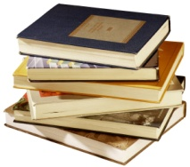

books _____ ______ ______

cook ______ ______ ______
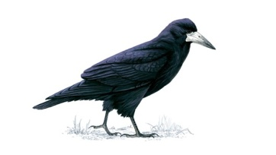

rook ______ ______ _______
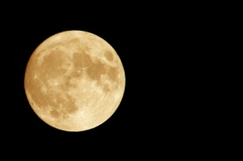

moon ______ ______ ______
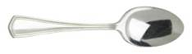

spoon ______ ______ ______

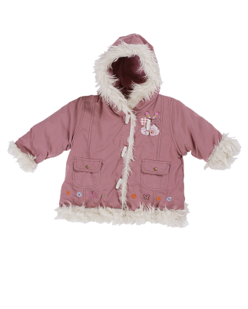
hood _______ ______ _______

Pages 1-5 Choose the correct word.

A rook sat on a _________ pot / spot.

“Oh, look at that _______ book / rook.

It had a bad _______ sting / wing.

Mum took the ______ food / rook.

“ Let’s call him ______ Don / Ron.

Draw the picture of the rook on page 1.

Pages 8- 11
Put the story in order.

Mum ran out.

Mum was cooking.

A magpie took the ring.

Mum took off her ring.

Who said it?

Look at that wing.
Page 2

_________________
No, I can tie the wing up.
Page 5

____________
Page 11
A magpie took my ring!

____________

My ring is in that tree.
Page 13
__________
It’s Ron the rook.
Page 11

____________

Page 16 “Well, well. I got my ring,” said ________________.

Pages 16
Ron is a good rook.

_______________________

Page 16

Draw the picture and label it.

Chip Dad Biff Floppy Mum Ron

Pages 12 - 14

Unscramble the sentences.

ran. and Dad Mum

Chip, Floppy and ran. Biff

___________________________________________________________

wood. magpie went The a to

Page 14 – 15

What did Chip and Biff say?

Pages 12 – 15

The magpie went to a wood.

Mum and Dad ran.

The magpie shot off.

Ron the rook got the ring.

Look at the pictures.

Yes or No?

A book sat on a pot. ________

Chip got Mum and Dad. ________

Dad took the rook. ________

Biff and Mum fed Ron the rook. ____________

Biff let the rook go. _________

Mum took off her ring. ___________
...................................................................................................................................

Draw Mum cooking. (page 10)

