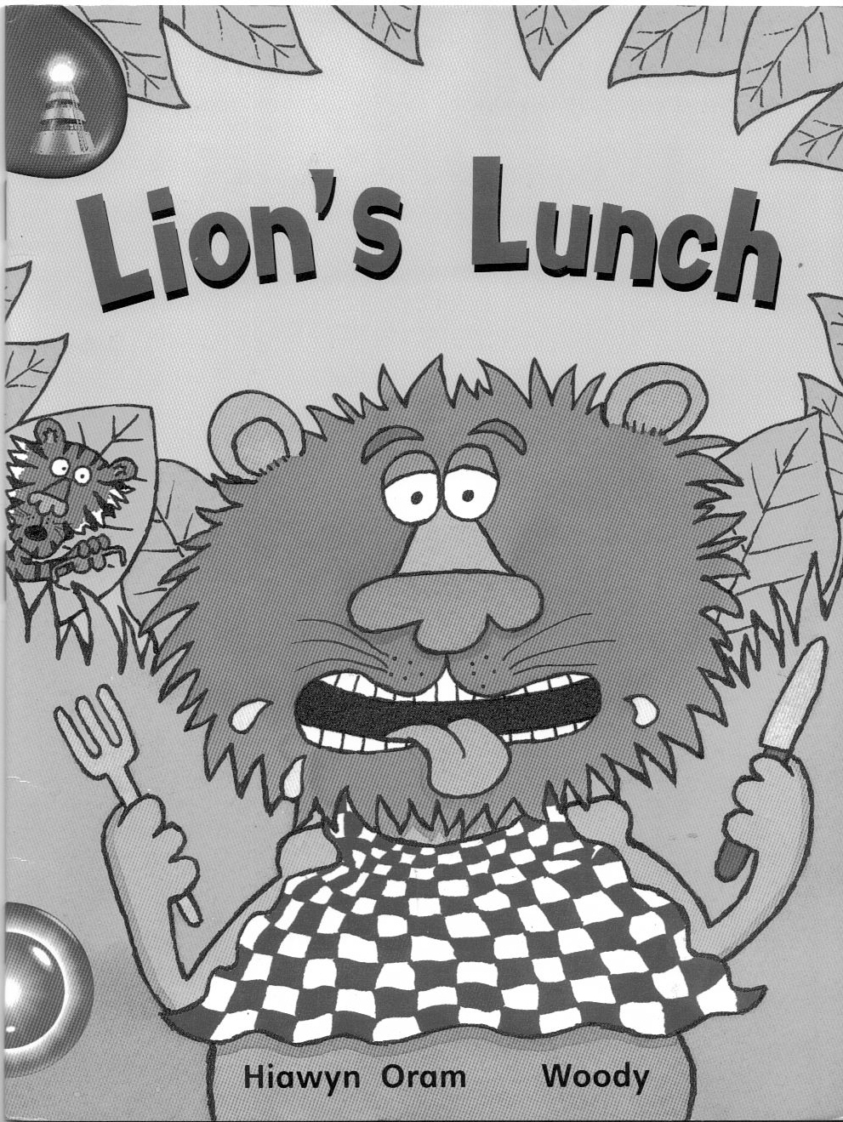

Name_____________________________________

(Blue Band)

Answer the questions in sentences.

1. Where were lion and tiger?

2. What did lion want?

3. Who did tiger meet first?

4. What did tiger tell the animals was wrong with lion?

1.__________________________________________________________________________________________________________________________

2.________________________________________ __________________________________________________________________________________
3.__________________________________________________________________________________________________________________________

4.___________________________________________________________________________________________________________________________________________________________________

Match the beginnings and endings of these sentences.

1. Lion and tiger were sick.

2. Tiger went lions lunch.

3. Lion is into the cave.

4. Look at the footprints going in their cave.

5. I’d soon be a outside.

Put the story in order.

A: Tiger told deer that lion was sick.

B: Fox noticed something strange about the footprints.

C: Lion and tiger were in their cave.

D: Lion was hungry.

E: The animals ran out of the cave.

Underline the correct answer.

1. Tiger told lion to go out and get his own
lunch
sandwich
dinner

2. Soon tiger saw hare coming
down the road
across the grass
along

3. Tiger told the animals that lion was
unwell
sick
ill

water
bath
cave
4. Tiger tried to get the animals to go into the

tracks
marks
footprints
5. Fox seen that no_______came out of the cave.

