L/O To improve my vocabulary.
Name__________________________________
Use the words in the box at the bottom of the page to fill in the missing
words in the sentences.
Then use a thesaurus to find a more exciting word choice!

- Shining brightly, the _ o _ sun shone over Athens.
- The _ c _ _ _ Hydra slithered menacingly towards Theseus.
- P _ _ _ _ _ Persephone had golden hair like a bright ray of sunlight.
- Laughing loudly, the King of Athens was very _ _ _ p y.
- Apollo, who was very _ t _ _ _ _ , lifted the heavy golden sword.
- Locked in the dingy underworld forever, Hades felt very _ _ d.
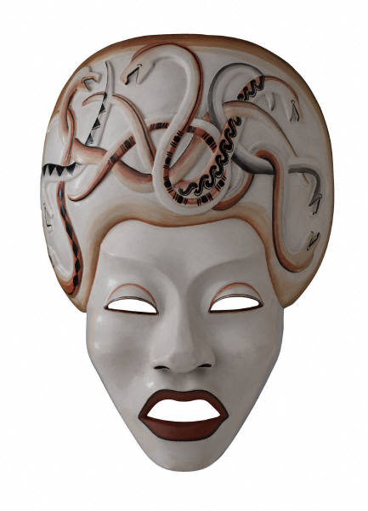
- The Minotaur, who was very _ _ g , towered over Theseus like a skyscraper.
- Jason got to his feet and began to w _ _ _ towards the golden fleece.
- Perseus h _ _ Medusa and knocked the gorgon to the stony ground.
walk hot scary big
pretty sad happy strong hit

