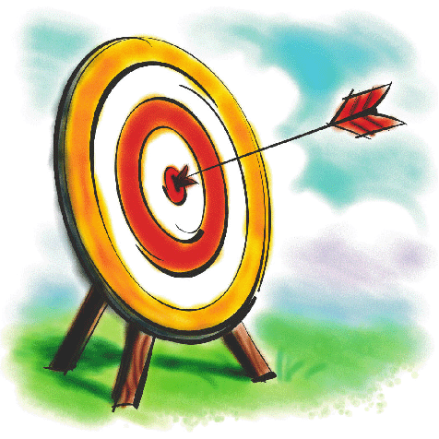
Name:
I can think of character ‘twists’.

Instead of……. | we could have…..
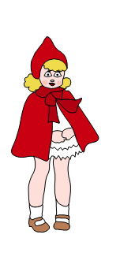
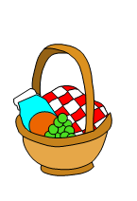
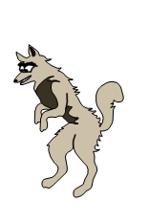
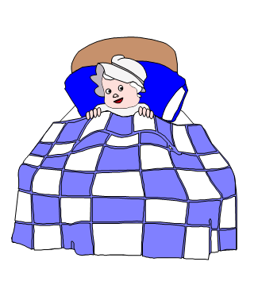
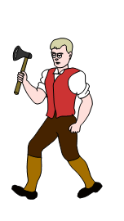

HA - I can think of action ‘twists’.

Instead of……. | we could have…..
going through the forest…. | going through
being carried in a basket… | being carried
wanting to eat people…. | wanting to
sleeping in bed…..
chasing the wolf with an axe….. | chasing the wolf with

