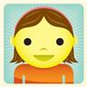

noun

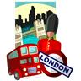
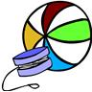

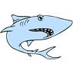

A noun is a naming word.
It is the name of an animal, person, place or thing.

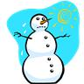
verb

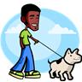
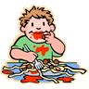

A verb is an action word, it is something that you do, like walk or play or eat. It is also something happening, like melts, shines and glistens.
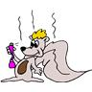
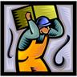
adjective


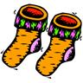

An adjective is a describing word. It usually comes before a noun and modifies it making it more interesting. Like scruffy dog, heavy box, smelly sock and shiny star.

