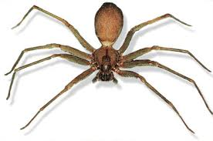
ORT Stage 16 Tree Tops
Pests, Plagues and Parasites

Mark
1. In what year was this book first published? 1
2. How is food taken all through the body? 1
3. What species can spread deadly diseases? 1
4. How do headlice survive? 1
5. Why can you not see dustmites in your bed? 1
6. What is the difference between truffles and most other parasites? 1
7. What two historical peoples believed mistletoe had special powers 2
7. What would Frigga do to you if she met you under the mistletoe? 1
8. In what century did the Bubonic Plague take place in Europe? 2
9. ‘The condition of the people was pitiful to behold’ Who said this? 1
10. What caused the black death? 2
11. How much was the population of Ireland reduced by as a result of the potato famine? 1
12. On what continent is malaria most feared? 1

A There is nothing good about parasites. True of False? Why? 4
B Scientists will discover a vaccine for Malaria next year. Do you agree or disagree. Why? 4
C Design and label your own parasite and explain how it survives. 4
Mr Masterson 2012

