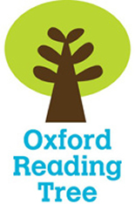
Name _____________

Barn Owls


Stage 3

My reading book is called _____________________
The author is ____________________
I think I am going to learn about_________________
__________________________________________
- Look at the Contents page.

Write down which page you will find out about -

Page
Sight
Owlets
owl pellets
Hidden
Barn Owls

- Look at pages 2 - 3 and annotate this diagram

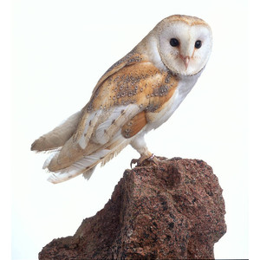

- Use the Glossary on page 16 to help you match these words and meanings.
owlets |  | to be sick
raptor |  | owl’s feet
talons |  | owl chicks
vomit |  | bird that kills animals for food
- True or False?
 | T | F
Barn owls are nocturnal.
It can keep out of sight in a tower.
They eat grass and soil.
Owls can see better than us.
They use their hearing to hunt for food.
Mummy owls get food for her owlets.
An owl can feed on hair and fur.

- Write down 2 facts you have learned about owls.
________________________________________________________________________________
________________________________________
________________________________________
________________________________________
Name _____________

A cool summer

Stage 3

- Look at the Contents page on page 17.

Write down which page you will find out about -

Page
On a boat
Pop on a hat!
Keeping cool
Summer Sun
Keep safe in the sun!

- Write down ways you can keep cool in the sun.
___________________________________________________________________________________________________________________________
- Fill in the missing words.
ducklings picnics summer fishing fun

p 23 You can go ______________ or surfing.

p25 You might see ducks and _________________.

p26 _______________ are fun in summer.

p30 In _______________, you need a cap or a sun hat.

p31 Sunburn is no ___________.

a b c d e f g h i j k l m n o p q r s t u v w x y z

- Put these words in alphabetical order.
summer picnic river
__________, __________, __________,
sun hot cool pool
__________, __________, __________,

