
Name _____________

Men on the Moon


Stage 3

My reading book is called _____________________
The author is ____________________
I think I am going to learn about_________________
__________________________________________
- Look at the Contents page.

Write down which page you will find out about -

Page
Moon cars
Back to the moon?
A man on the moon
The moon
Looking at the moon

- Colour each word that has the correct sound.

ck | quicker | rocket | visit | pocket
oo | look | living | moon | boot
igh | night | might | car | lights

- Fill each sentence with the correct word.

The sun ____________ up the moon. p3

The first __________ on the moon was American p5

In 4 years, 12 men set ____________ on the moon. p8

All the men had a ________ look at the moon. p12

Will _______ be living on the moon soon? p15

- Look at the Index on page 16.

Write down which pages you will find out about -

Pages
pits
soil
boots
visit
a b c d e f g h i j k l m n o p q r s t u v w x y z

- Put these words in alphabetical order.

rocket night moon sun

__________, __________, __________, __________

boot pocket tools car

__________, __________, __________, __________

- Look at pages 8 - 9 and annotate this diagram
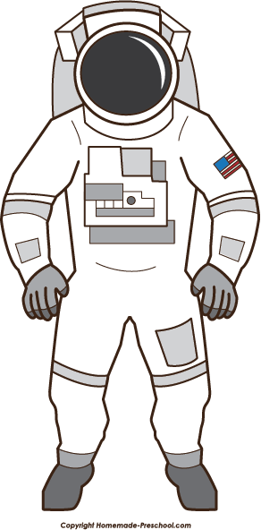

Name _____________

Muffins

Stage 3

- Look at the page 18.

Write down 6 tools you will need to make muffins.

- Look at the page 19.

Write down 4 ingredients you will need to make muffins.

- Finishing writing these instructions for cooking muffins.
First ________________________________
Then ________________________________
____________________________________
Next ________________________________
After that ___________________________
Finally _______________________________
_____________________________________
add an egg, oil and milk to the muffin mix.
add a filling.
fill the muffin cups and bake in the oven.
turn the oven on.
mix well.

- Draw 2 pictures to show what you have learned about baking muffins and write a sentence under each one.

____________________________________________________________________________________

____________________________________________________________________________________

