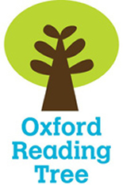
Name _____________


Dinosaurs

Stage 6

My reading book is called _____________________
The author is ____________________
I think I am going to learn about_________________
__________________________________________
- Look at the Contents page.

Write down which page you will find out about -

Page
Dinosaurs like birds
The longest time
Big and Small
Meat-eating Dinosaurs
Heads
Fossils
Index

- Use your book to write down ONE fact about each of these dinosaurs. Use the Index on page 24 to find the page to look at.
Brachiosaurus __________________________
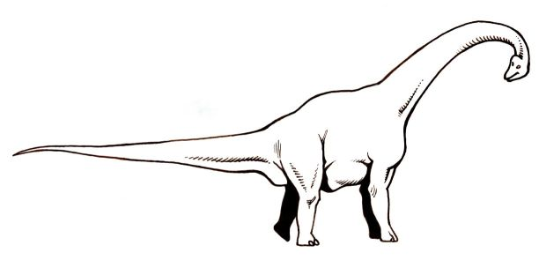
________________________________________________________________________________

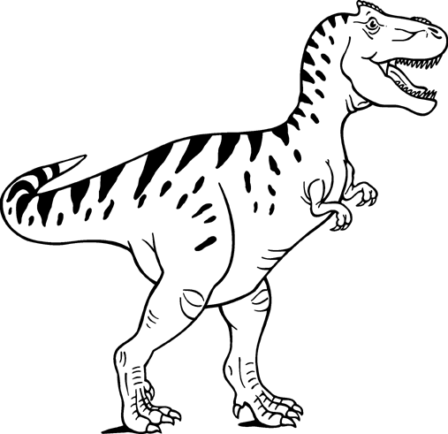
Tyrannosaurus _________________________
________________________________________________________________________________

Triceratops _______________________________
________________________________________________________________________________
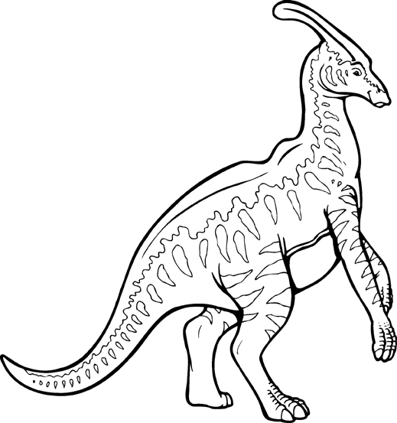
Parasaurolophos ___________________________
________________________________________________________________________________

- Words ending with –ed tell us that something happened in the past.

Skim through the book and find words that end in ‘ed’. Write them below.

- Use your book to find the correct information. Draw a line to match the statement with the correct dinosaur.

Troodon p8 | had a head shield
Euoplocephalus p11 | had a frill around its neck
Centrosaurus p12 | had sharp spikes on its tail.
Protoceratops p17 | hunted in the dark
Kentrosuarus p12 | swallowed its food whole
Brachiosaurus p9 | had a club on the end of its tail

- Fill in the missing words.
Saltopus baby herbivores fishing fun

p 12 Plant-eating dinosaurs were called ______________.

p5 ______________ was smaller than a cat.

p13 A __________ dinosaur could be as long as your arm.

p19 Some dinosuars may have _________

a b c d e f g h i j k l m n o p q r s t u v w x y z

- Put these words in alphabetical order.
summer picnic river
__________, __________, __________,
sun hot cool pool
__________, __________, __________,

