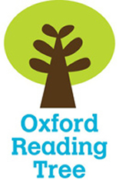
Name _____________


Unusual Buildings

Stage 6

My reading book is called _____________________
The author is ____________________
I think I am going to learn about_________________
__________________________________________
- Look at the Contents page.

Write down which page you will find out about -

Page
Junk Castle
Introduction
Adobe Houses
The Glass Elephant
Futuristic Buildings
Pyramids
Index

- Fill in the missing words from the ‘Introduction’.
shape many buildings made glass

There are _________ buildings in the world that are unusual. Some are not a ___________ you are used to and others are __________ from different materials. Some ____________ are made from mud, snow, junk or __________ bottles.
a b c d e f g h i j k l m n o p q r s t u v w x y z

- Put these words in alphabetical order.
clay materials snow
_____________, _____________, _____________
space ice air light
__________, _________, __________, _________

- Use your book to write down ONE fact about each of these unusual buildings.
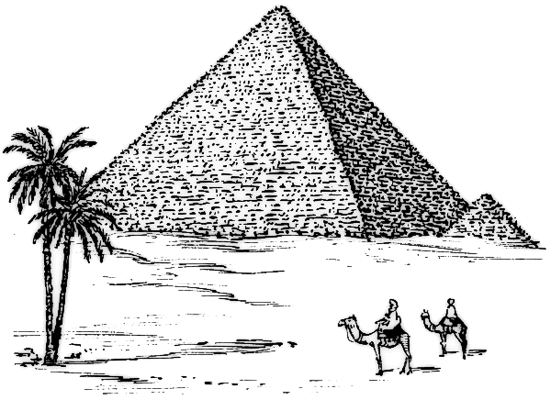
Pyramids _________________________________
________________________________________________________________________________
__________________________________

Boswell Bottle House ________________________
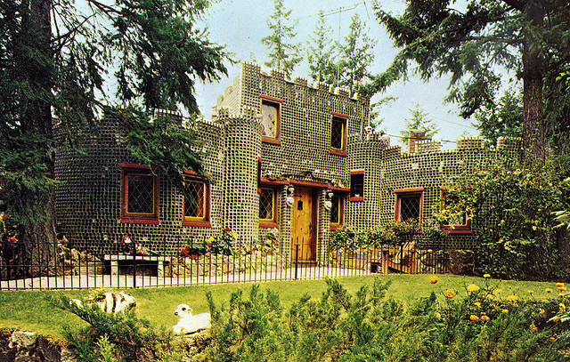
__________________________________________________________________________________
_________________________________________

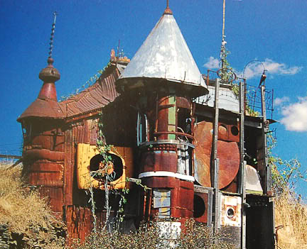
Junk Castle _______________________________
________________________________________________________________________________
_____________________________

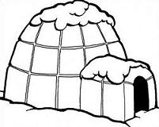
Igloos _________________________________
__________________________________________________________________________________

- Work with an adult and find these words in a dictionary. Write down a simple definition.

bricks - ________________________________
______________________________________

junk - __________________________________
_______________________________________

clay - __________________________________
_______________________________________

- Look at the Index on page 24.
Write down which pages you will find out about -

Pages
materials
Germany
snow
dome
air
space

