
Name _____________


Fire

Stage 7

- Look at the Contents page.

Write down which page you will find out about -

Page
The Great Fire of London
The Alexandria Library Fire
The Japan Earthquake Fire
The Great Peshtigo Fire

- Fill in the missing words from the ‘Introduction’.

Fire is very ___________. It can _________ people warm. __________ can be cooked using fire.
Fire can _________ be dangerous. It damages buildings and ____________ and kills thousands of ___________ every year.
- Use the Contents to find ONE fact about each of these fires.

The Great Fire of London
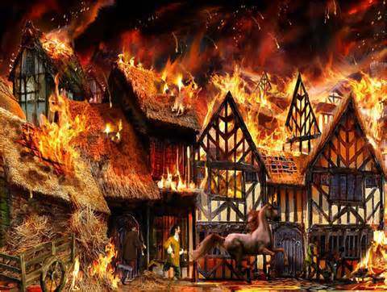
__________________________________________________________________________________
__________________________________________________________________________________

The Ash Wednesday Fires
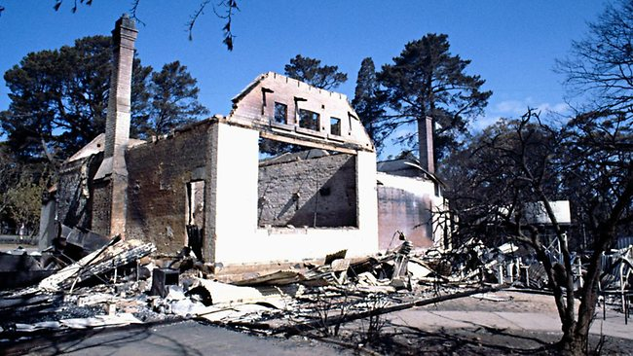
__________________________________________________________________________________
_________________________________________
_________________________________________

The Great Chicago Fire
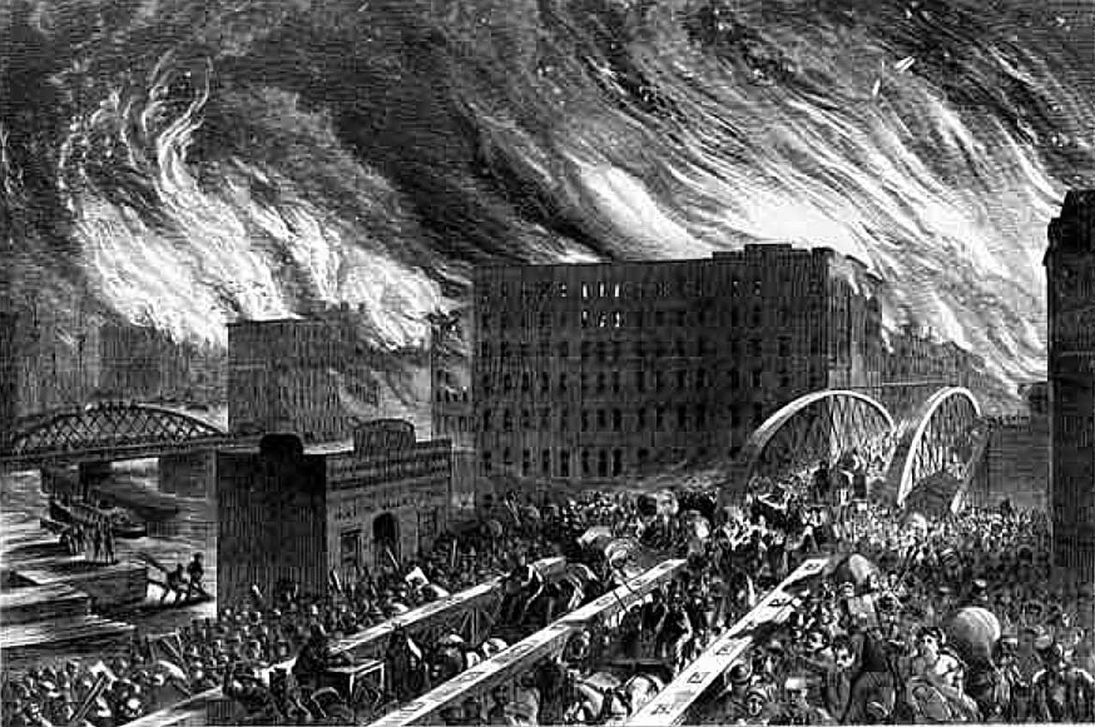
__________________________________________________________________________________
_________________________________________
_________________________________________

- Write down the captions on -
page 5 __________________________________
_______________________________________

page 9 __________________________________
_______________________________________

page 21 _________________________________
_______________________________________

- Use your book decide if the statement is true or false. Look up the word in bold using the Index.

 | True | False
Matches can set grass on fire.

The Great fire of London killed many people during the Black Death.
Hot, dry weather caused the fire in Peshtigo in the USA.
75 farm animals died in the bush fires in Australia in 1983.
10% of fires are caused by lightning.

- Design a poster to warn people about the dangers of starting fires.

