Name________________ ORT – Stage 4 more stories

Everyone Got Wet

- Look at page 1.
What colour is Mum’s hose? Blue red green yellow
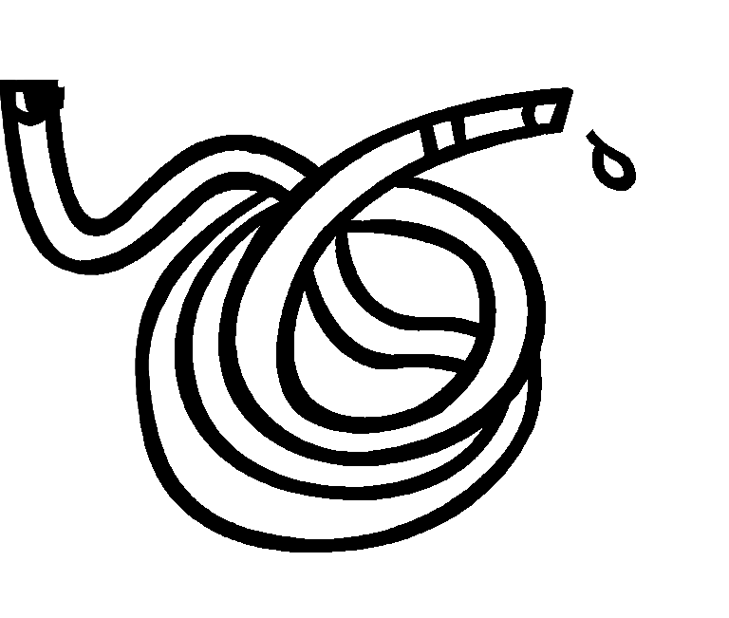

- Look at page 2 and 3.
Where is floppy? Outside the house [ ]
Inside the house [ ]
On the roof [ ]

3. What did mum say? “__________________________”

4. What did Dad have to mend? Car robot water-butt

5. Look at page 6. Can you draw what happened?

6. Who mended the hose? Mum Dad Biff Chip
Everyone Got Wet

1. Look at page 18.
Who turned on the tap? ___________________________

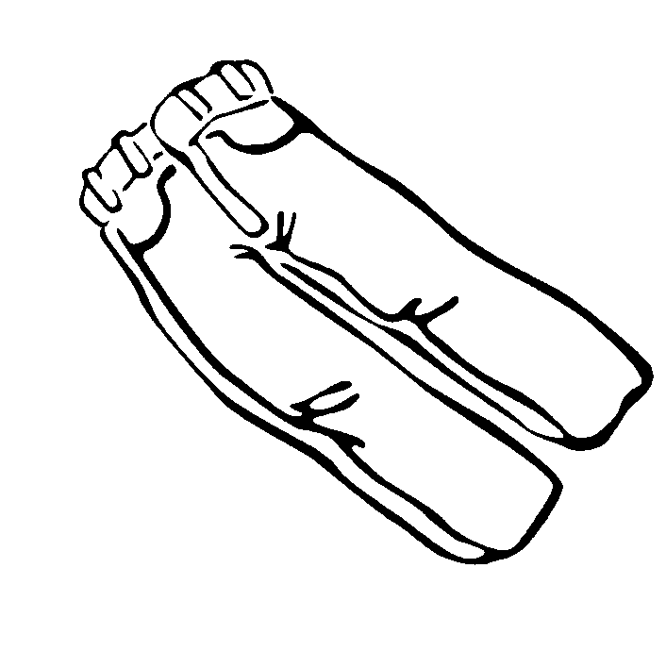
2. Look at page 20
What colour are the trousers Mum is hanging up?

Red green blue purple

3. Where did the children put the paddling pool?

On the roof on the path on the grass

4. How many people in the story got wet? ________

List their names below. Draw them getting wet.

__________________________

__________________________

__________________________

__________________________

__________________________

