Name________________ ORT – Stage 4 more stories

Swap!

1. Look at page 1.
What did Nadim find? Car bike bat

2. Look at page 2 and 3.
How many chairs can you see? ________

3. What did Nadim swap his bat for? Mug book robot

4. Draw the thing he painted silver.

5. Match the words to the pictures.

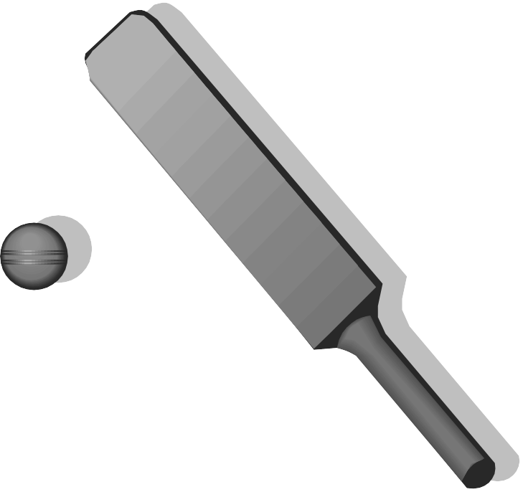

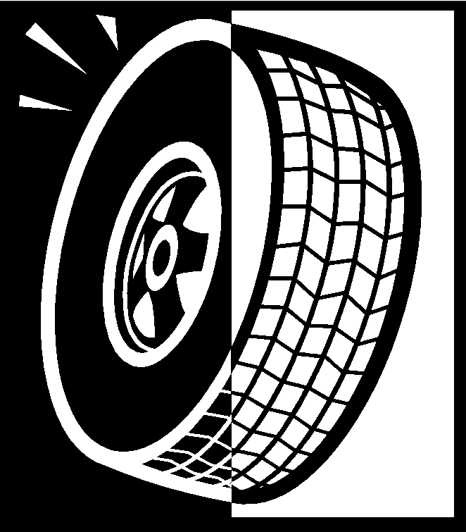
Bike

Skateboard

Robot


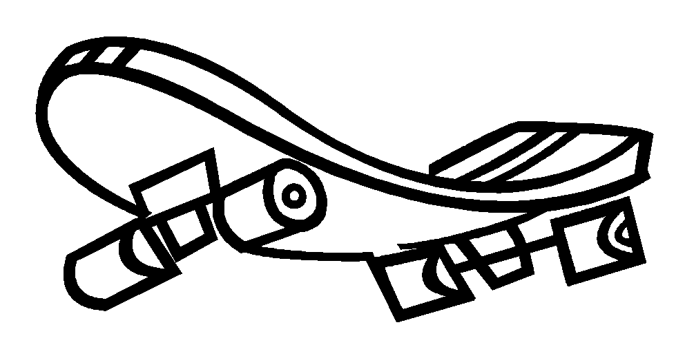
Wheel

Bat

Swap!
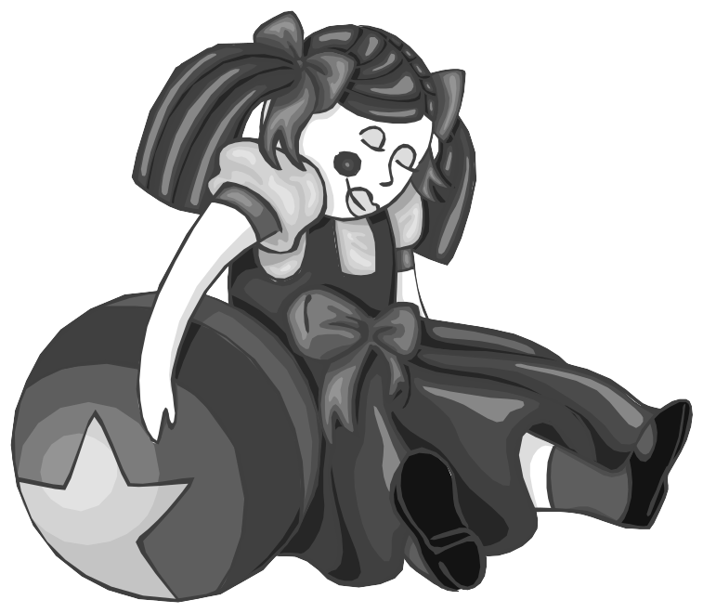
1. What did Nadim mend? Colour the correct ones.

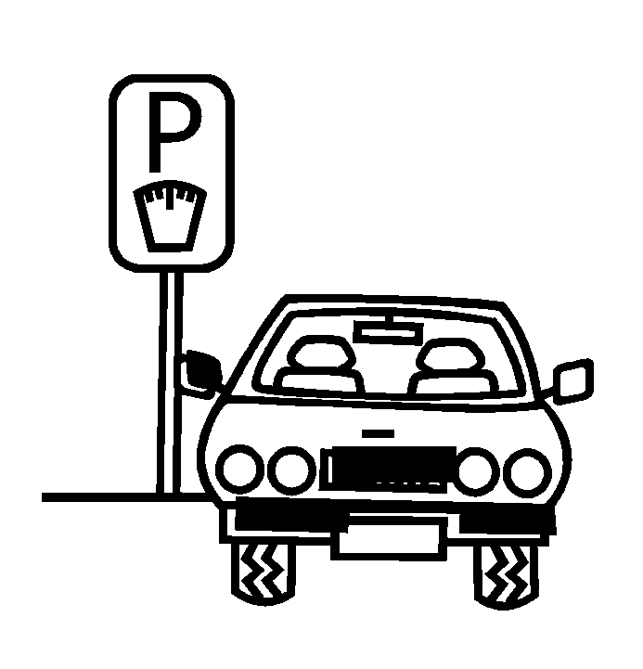


2. What colour is Nadims jumper? Red blue green

3. Look at page 9.
What is Dad reading at the table? _________________________

4. Look at page 12 and 13.
What number is on Wilma’s door? ________________

5. What colour is the bike? __________________ __________________

6. Look at page 16.
How do you think Nadim feels? Draw his face in the circle.

