Oxford Reading Tree

Stage 4 Resources

Contents …

- Poor Old Mum
- The Camcorder
- The Wedding
- The Storm
- Nobody Got Wet
- The Weather Vane
- The Play
Week commencing:

19th Nov 07
Title: ‘Poor Old Mum!’
ORT – Stage 4

Tues:
Wed:
Thurs:
Word Hunt:
Mon:
Parent’s Signature
What type of book is it? In the title:
Can you spot the oo sound?
Read the blurb.
Find the word race. Talk about the magic e at the end of this word. Discuss its function – to make the vowel a make its letter sound ‘a’ instead of its sound ‘ah’ like in ‘Wilma’.

Picture walk – talking through what the main characters are doing in the book. Read pages 1-8. Chat about story.
Read pages 8-16 and chat about the story. Talk about vowels – a e i o u again. Remind your child that all the other letters are consonants.
Choose a word on any page and count how many vowels and consonants it has.
Change roles with your child. Let them pick the words and check if you got the V and Cons right!

Word Hunt:

camefirst had jump

lastoldput were what

Read all of the book. What was your favourite part of the book? How would you have surprised your Mum if she had taken part in the race? Play word hunt. Read extra reader.

Play word hunt. Read your extra reader.
Read your extra reader.
Week commencing:

3rd Dec 07
Title: ‘The Camcorder’
ORT – Stage 4

Tues:
Wed:
Thurs:
Word Hunt:
Mon:
Parent’s Signature
Recap on the parts of the text: spine, blurb, title, author, publishers logos.Take a picture walk through the book – talk about what each character is doing in the story.
Read pages 1-8: Read pages 1-8 together. Find the word ‘camcorder’. How many times does this word appear in these pages. Practice breaking down this word to make it easier to read. How many ‘wee’ words can you see inside this long word?
Repeat this step for the word ‘anniversary’.
Read pages 8-16 and chat about the story.
If you watched Dad’s video – what would you see?
How do you think Wilma felt when she saw the burglars?
Turn to pages 12/13 – how many doing words can you read?

Play picture i-spy like last week.

Word Hunt:

callcamegot her
househadmakesaw
laughedmadethem took
two wanted were

Read to the end of the book. Point to the parts of the text were someone is speaking. How do you know someone is speaking? NB the speech marks. What was your favourite part of the book and why?

Read extra reader.

Play word hunt. Read your extra reader.
Read your extra reader. Play word hunt.
Week commencing:

26th Nov 07
Title: ‘The Wedding’
ORT – Stage 4

Tues:
Wed:
Thurs:
Word Hunt:
Mon:
Parent’s Signature
Recap on the parts of the text: spine, blurb, title, author, publishers logos.
Take a picture walk through the book – talk about what each character is doing in the story.

Read pages 1-8: Talk about compound words – these are two words joined together. Can you find any compound words on pages 1-8? Answer: bridesmaid, pageboy, grandparents, grandmother
Read pages 8-16 and chat about the story.
Why did Wilf say he didn’t like Weddings?
Did his feelings change later in the story?
Imagine you had a Wedding outfit. Describe what it looks like.
Play picture i-spy: Choose any picture from the story. Choose a thing, such as horseshoe in Wilf’s hand, and say “I spy with my little eye something that begins with ‘h’. Now test mum/dad. Have 2/3 turns each.

Word Hunt:

be beencame don’t had helped not put sister there took want what will

Read to the end of the book. What was your favourite part of the book? Turn to page 22/23 – the dance scene! Look at the picture – try to come up with as many doing words as possible – ie. hopping, jiving, jumping.
Read extra reader.

Play word hunt. Read your extra reader.
Read your extra reader. Play word hunt.
Week commencing:

1st Oct 07
Title: ‘The Storm’
ORT – Stage 4 Stories

Tues:
Wed:
Thurs:
Word Hunt:
Mon:
Parent’s Signature
Discuss the main features of the book as before. What type of book is it? Fiction/non fiction? What does fiction mean? Take a picture walk through the book – talking through what the main characters are doing in the book. Read pages 1 – 8.
Initial sounds – turn to page 12. Point to the things that begin with the following sounds: c – e.g car. tr, um, l, s, h, b.

Recall what has happened so far. Read pages 8-16. When reading identify who is speaking on each page before reading that page through. Encourage your child to give the characters an expressive voice when there are exclamation marks – “What a _____!.
End sounds: Turn to page 24. Find things that end in the sounds: p, d, ox, hip, low.
Word Hunt:

bed came door good helped

her time wanted what put
Read all of the book. What was your favourite part of the book? What would you have liked to have found in the box. Find your favourite picture and tell mum or dad all about it. Play word hunt. Read your extra reader.
Read your extra reader.

The Storm
Name:
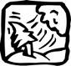
Fill in the gaps.

There ________ a storm.
The rain ________ down.
It _______ time to _____ home. Floppy found __ box.
Chip ____ it in his room.
came was

a go

put was
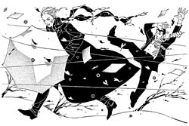

Circle the thing or things that end with:
x
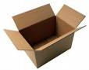

ee
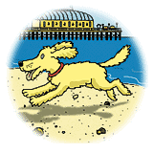

f

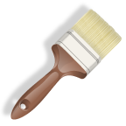

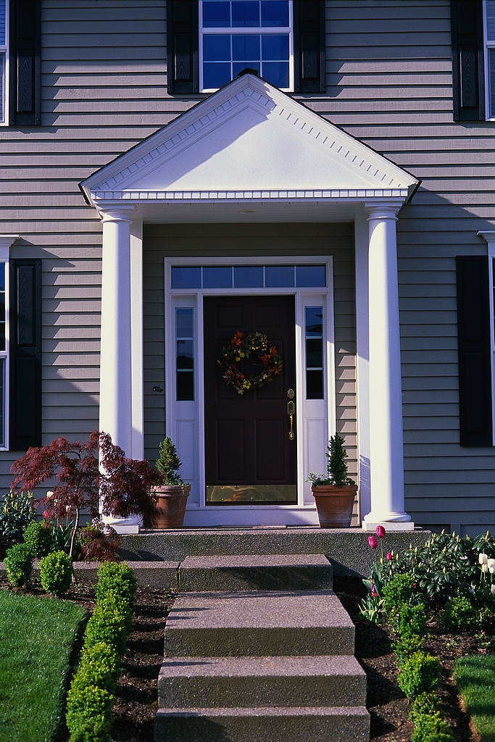
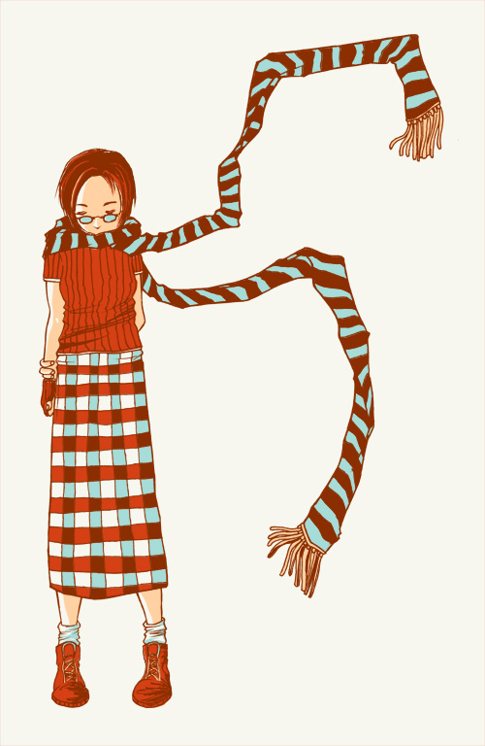
Write a sentence about your favourite part of the story.

_____________________________________________

Week commencing:

8th Oct 07
Title: ‘Nobody Got Wet’
ORT – Stage 4 More Stories A

Tues:
Wed:
Thurs:
Word Hunt:
Mon:
Parent’s Signature
Discuss the main features of the book as before. What type of book is it? Fiction/non fiction? How many small words can you see in the title? Talk about the ‘oa’ double sound in boat. Tell your child that this gives a ‘o’ sound. A useful phrase is: The first vowel does the talking- the second does the walking! Take a picture walk through the book – talking through what the main characters are doing in the book. Read pages 1 – 8.

Recall what has happened so far. Read pages . Talk about capital letters and full stops and how they make sentences. Encourage your child to read to the end of each sentence rather than to the end of each line. Page 10 – talk about the ‘oa’ sound in ‘float’. End sounds Focus: Turn to page 14 and 15. Find things in the picture that end in the sounds: a, t, er. Turn to page 6 and 7. Find things that end in the sounds: oat, a, ck. Can you find a word with a ‘oo’ sound on page 7. [answer ‘good’]
Word Hunt:

but don’t downgood
gothadhelphome
outpushedpulledtime
Read all of the book. What was your favourite part of the book? Tell your mum or dad about the times the family nearly got wet – there where lots! Find your favourite picture and tell mum or dad all about it. Play word hunt. Read your extra reader.
Read your extra reader.

a

1. Who got a boat?
boat.
Dad
got
2. When it was raining what did the family do?
They
picnic.
had
a
3. How did the family get wet in the end?
by
car.
splashed
got
They
a

Your name begins with a capital letter. Eg. Rachel begins with a big R.

They are big letters.

Circle the words that begin with a capital letter.
a
Yum
yum!
Oh no the a monster has gobbled up all the as! Can you help me to put back the as back into the right words please?

Name:
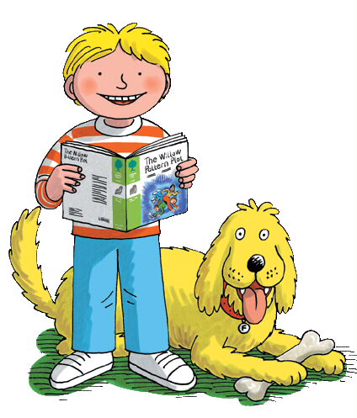
An but

came Take

Man jump

Good Back

took What

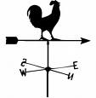

c __ t
m __ n
b __ d
r __ t
l __ p
j __ m
t __ p

b __ x
b __ g
b __ t
r __ g
r __ t
m __ g
p __ n
h __ t
p __ g
Name:
Draw a picture of the weather vane. Write words to describe it.

Can you help me add capital letters and full stops to the sentences below so that they make sense.
Name:
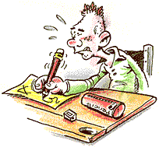
1. they looked at the crane

2. dad had an idea

___________________________________________

3. wilf took a photograph
___________________________________________

4. they jumped over the weather vane

___________________________________________

‘The Play’

Biff and Chip went to _________________. They read a

_______________ called The Wizard of Oz. The children

made a little __________. Wilf’s _________ painted a

house. __________ was a witch. The children gave

Mrs. May some _____________.
Word box

flowers dad play

school story Biff

Fill in the gaps using the word box.
Name: _____________

‘The Play’

Biff and Chip went to _________________. They read a

_______________ called The Wizard of Oz. The children

made a little __________. Wilf’s _________ painted a

house. __________ was a witch. The children gave

Mrs. May some _____________.
Word box

flowers dad play

school story Biff

Fill in the gaps using the word box.
Name: _____________

