Oxford Reading Tree

Stage 5 Resources

Contents …

- The Great Race
- It’s Not Fair
- Underground Adventure
- The Whatsit
- Castle Adventure
Fill in the rest of the sentences to answer the questions.
Remember to add full stops at the end of each sentence.

1. What kind of car did Gran buy? [page 3]

The children bought _______________________

2. Why was mum cross with Gran? [page 4]

Mum was cross with Gran because _______________________________________
_______________________________________

3. What was the bad man called [page 9]

The bad man ____________________________

4. How did bad man try to trick Gran? [page 11]

The bad man _____________________________
_______________________________________

5. What was your favourite part of the story?

My favourite part _____________________
____________________________________________________________

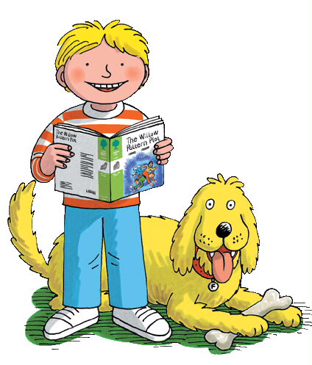
Now read the sentences to make sure they make sense.
Oh no! I forgot to add capital letters and full stops! Write out the sentences below with capital letters and full stops so that they are easy to read. There are 3 sentences in each question.

Name:

1. gran wanted a new car biff and chip were sad they liked gran’s old car
__________________________________
____________________________________________________________________

2. a man looked at gran he was a bad man he was called a baron
__________________________________
__________________________________________________________________________________________

3. the baron was behind gran was in front she was winning the race
_______________________________________________________________________________________________________________________________________
__________________________________________________________________________________________________________________________________________________________________________________________________________________________________________________________________________________________________________________________________________________________________________________________________________

You go on your a magic adventure. You are in a race and met a baddy. Draw a bad character below and tell me what he does to try to stop you from winning.
Name:
Answer these questions in full sentences below.

Remember to start your sentences with capital letters and remember to end your sentences with full stops.
Eg. Who was ill?
Mrs May was ill.

1. What was the new teacher called? [page 1]

The new teacher was called _______________.

2. Who was the story about? [page 3]

The story was about _____________________________.

3. What did Biff want to be? [page 7]

Biff wanted to _____________________________

4. How do you think Biff felt when she couldn’t be a knight? [page]

I think _______________________________________

5. How did Biff solve the knights problem? [page 20]

Biff told King Arthur ____________________________

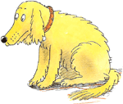
Can you help me add capital letters and full stops to the sentences below so that they make sense.
Silly me! I forgot to put capital letters and full stops in my sentences so that they make sense.

Name:
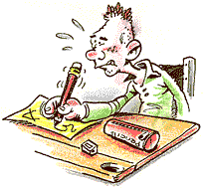
1. biff wanted to be a knight

2. it put her in a dress

___________________________________________

3. the knights laughed
___________________________________________

4. no one wanted to sit down

___________________________________________
Design your own knight’s outfit below. Write adjectives to describe this outfit.
______________________________________________________
Name:
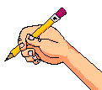

______________________________________________________
Page 17
laughed
Page 18

Page 17
Match the adjectives to the pictures on each of the following pages.

pointed

sat
skateboardeddded
tossed
Write a sentence using at least 2 of the adjectives above.
____________________________________________________________________________________________________________________________________
Page 15

Page 24

Page 22

word
box

Underground Adventure
Fill in the gaps.

The children were in the ______________. They found a ___________ tunnel. They met __________ in the tunnel.
“Whooooooa!” called ___________. The _______ had an echo. The elves had ______ work. __________ had an idea.
The elves ____________ some signs and put ___________ in the caves. People _________ to see them. __________ to the children they said.
came cellar no

secret Kipper Wilma

elves cave painted

lights thanks
Name:

Circle the words.

find were

busy idea

tapped

lamp

echo

go

too

witch

l
t
e
e
a
f
a
a
o
r
e
i
m
p
h
e
n

n

p
p
c
w
i
d
h
e
e
d
o
o
g
d
e
l
d
o

u
a
c
y
s
b
Make a sign to put outside the elves cave.
Oh no! There is a finger space thief!
Write out the sentences below with finger spaces so that they are easy to read.

1. MumandDad paintedthe kitchen. [page 1]
__________________________________

2. Dadlookedat thecarpet. [page 3]
__________________________________

3. Thechildrenlooked in. [page 7]
__________________________________

4. Theladywantedthewhatsit. [page 18]
__________________________________

5. The ladygaveDad somemoney. [page 22]
__________________________________

6. Thewhatsitwas asnookertable. [page 24]
__________________________________
Name:
Fill in the rest of the sentences answer the questions.
Remember to add full stops at the end.

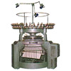

1. What did Mum find? [page 4]

Mum found a ____________________________

2. What word did the children use to describe the cellar? [page 7]

The children said the cellar __________________

3. What did Kipper pretend to be when he was in the cellar? [page 9]

Kipper pretended _________________________

4. What was the whatsit used for? [page 20/21]

The whatsit was used ______________________

5. What was your favourite part?

My favourite part _____________________
____________________________________________________________

Now read the sentences to make sure they make sense.
Fill in the rest of the sentences to answer the questions.
Remember to add full stops at the end.

1. What did Mum find? [page 4]

Mum found a ____________________________

2. What word did the children use to describe the cellar? [page 7]

The children said the cellar __________________

3. What did Kipper pretend to be when he was in the cellar? [page 9]

Kipper pretended _________________________

4. What was the whatsit used for? [page 20/21]

The whatsit was used ______________________

5. What was your favourite part?

My favourite part _____________________
____________________________________________________________

Now read the sentences to make sure they make sense.
hadputon

weresawfloor

turned kingwitches

threwold

Castle Adventure
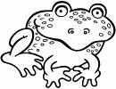
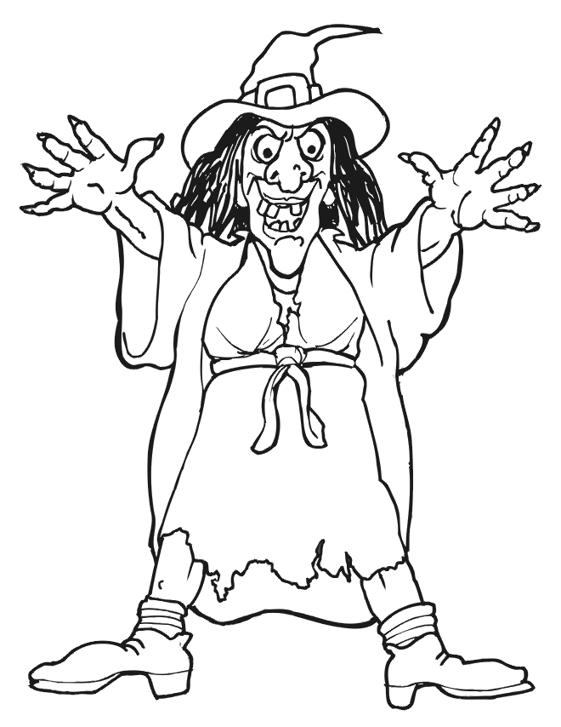
Name:

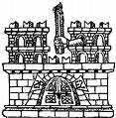
Fill in the gaps using the words below.

Three ________ lived in the castle. They ______ nasty. Gran and the children _____ a frog. He was the ________ of the castle. Gran __________ the green witch ____ the ________. “Good _____ Gran,” said the children. The frogs ________ into people. Gran _____ the book on the fire. They _______ a party.

