Oxford Reading Tree

Stage 6 Resources

Contents …

- The Shiny Key
- In the Garden
- A Fright in the Night
- Land of the Dinosaurs
- Rotten Apples
- The Treasure Chest
- The Go-Kart Race
- The Laughing Princess
- Christmas Adventure

Can you help me add capital letters and full stops to the sentences below so that they make sense.
Silly me! I forgot to put capital letters and full stops in my sentences so that they make sense.

Name:
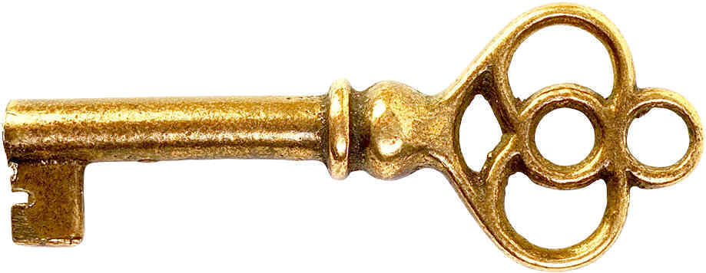
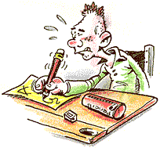
1. chip lost the magic key

2. the key was stuck in toffee

___________________________________________

3. the magic key was stolen by the magpie

___________________________________________

4. the soldiers grabbed the children

___________________________________________
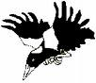
Turn to page 16 and 17 in ‘The Shiny Key’.

Make a list of as many verbs you can see in the picture.
Write a sentence using 2 or more of the verbs above.
You’re a star! Well done!
Remember capital letters and full stops.
_________________________________________________
_________________________________________________
_________________________________________________
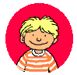
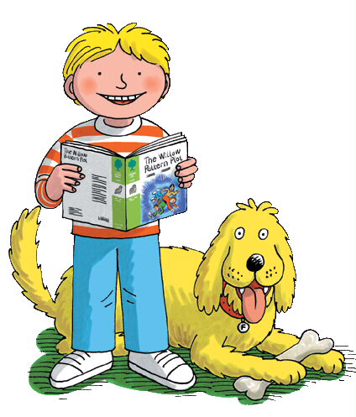
Name:
Answer these questions in full sentences in your literacy book.

Remember to start your sentences with capital letters and remember to end your sentences with full stops.

Eg. Who stole the key?
The magpie stole the key.

1. Who lost the key? [page 3]
__________ lost the key.

2. How did he loose the key? [page 2]

3. What kinds of things did Chip and Nadim find in the sofa? [page 5]

4. How did the key become shiny? [page 7]

5. Describe the wood the children arrived in. [page 10]

6. Why did the soldiers grab the children? [page 12/13]

7. How do you think the children felt when they found out that it was the magpie that stole the ring?

8. If you were captured by the soldiers how would you escape?

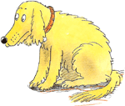

What did the children do in the desert? Write at least five sentences about what they did. [pages: 11-18]
What did the children do in the desert? Write at least five sentences about what they did. [pages: 11-18]
What did the children do in the desert? Write at least five sentences about what they did. [pages: 11-18]
Compound Words

Read your extra reader.
Read all of the book. What was your favourite part of the book? Have you ever played a scary trick on anyone? Find your favourite picture and tell mum or dad all about it. Play word hunt. Read your extra reader.

Week commencing:

8th Oct 07
Title: ‘A Fright in the Night’
ORT – Stage 6 More A

Tues:
Wed:
Thurs:
Word Hunt:
Mon:

Parent’s Signature

Discuss the main features of the book as before. What type of book is it? Fiction/non fiction? What do you notices about the title? Talk about the ‘ight’ sounds? Can you think of another ‘ight’ word? Take picture walk through the book. Read pages 1 – 12. Whilst reading identify who is speaking on each page. Continue to encourage your child to give the characters expressive voices.
Find 3 verbs on pages 1 / 6 / 10
Recall what has happened so far. Read pages 12-24. Look at page 21 and find the word ‘downstairs’. This is a compound word – it is made up of 2 words down + stairs. Can you find the compound word on pages:2. 4, 8, 17. Note them below.
Word Hunt:
bedroom small plastic

blackberries pick labels

laughed ghosts sheet

couldn’t switched
Circle the compound words.

Ooooooh! I forgot to add finger spaces!
Write out the sentences below with finger spaces so that they are easy to read.

laughed sheet fireplace

noise outside downstairs room

bottle blackberry

1. BiffandChip wenttostay withGran. [page 1]
__________________________________

2. Biffwantedthebed bythedoor. [page 3]
__________________________________

3. Hewasn’tfrightened. Hepulledthe sheetoffBiff. [page 12]
__________________________________
__________________________________

4. FatherChristmashadnodinner. [page 17]
__________________________________
__________________________________

5. WilfandWilma madesome strawberryjamsandwiches. [page 22]
__________________________________
___________________________________

6. Thewhatsitwas asnookertable. [page 24]
__________________________________
Name:
__________________________________________________________________________________________________________________________________________________________________________________________________________________________________________________________________________________________________________________________________________________________________________________________________________

Inside the broom cupboard you find a scary monster. Draw him below and write verbs to describe what he does.

Look through a ‘Fright in the Night’. Find as many compound words as you can in the story.
- Write the page number beside each word.

Eg. bedroom – page 2

______________________________________________________________________________________________________________________________________________________________________________________________________________________________________________________________________________________________________________________________________________________________________________________________________________________________________________

Name:
Compound words are made up of 2 words glued together.
Inside is a compound word. It is made from the words:

in + side

Land of the Dinosaurs
shoe through land fierce

help climbed eat Nadim

crack flying photograph
Fill in the gaps.

The children went _____________ the door of the magic house. They were taken to the ______ of the dinosaurs. Biff took a _______________ of a giant footprint. _________ found some eggs. The egg began to __________. The __________ dinosaur tried to ______ one of the eggs. Wilf ___________ on to a dinosaur’s back. “Oh _____!” he shouted. The children ran away from a _________ dinosaur and Wilf’s ________ fell in the mud.
Name:

Circle the words.
Draw your favourite part of the story.
Write a sentence to tell me about what you have drawn.

__________________________________________________________________________________________________________________________________

egg hurt

hatch yelled

teeth hill

stick flew

a
y
h
c
t
h
r
e
u
t
s
d
h
l
r
a
t
e

t
f
t

i
i
l
e
l
r
l
c
l
e
e
l
y
k
e

t
w
e
g
g
y
Name:
Answer these questions in full sentences below.

Remember to start your sentences with capital letters and remember to end your sentences with full stops.
Eg. Who picked up an apple?
Biff picked up an apple.

1. What did Biff notice about the apples?

The apples were _______________________________.

2. Where was the story set?

The story was set _____________________________.

3. Who had some birds going cheap?

____________________ had some _________ going cheap.

4. Describe Harry Smith.

Harry Smith is ____________________________________

5. Why did the horse fall over?

The horse _____________________________________


______________________________________________
______________________________________________
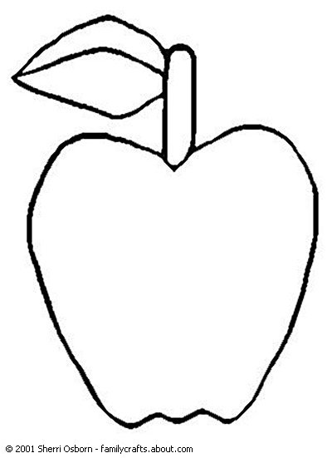
Name:

Draw a new outfit for Harry Smith.

List adjectives to describe it below.
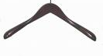

Rotten Apples
present cart fast sway box

horse drunk picked

apples greedy
word box
Fill in the gaps.

Biff ___________ up all the rotten __________ . She fed an apple to Harry Smith’s ___________. The horse ate the whole _______ of apples. “What a ___________ horse!” said Biff. The children climbed up on the ________. The horse ran very ________ and began to ________. It was _____________ from all the rotten apples. Harry Smith gave the children a _____________.
Name:

6

7
5
4
3
Fill in the words to find out where Biff should have put the rotten apples in the first place.
- Biff _ _ _ _ _ _ up an apple. [page 2]

- Harry Smith told them _ _ _ _ _ the horse. [page 13]

- “Yuk! Rotten _ _ _ _ _ _ !” Biff said. [page 4]

- Harry Smith wore a top _ _ _ . [page 7]

- Harry Smith rang a _ _ _ _. [page 8]

- He had some _ _ _ _ _ going cheap. [page 8]

- “Oh _ _ !” said Biff. [page 12]

2
1
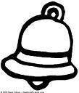
Harry Smith rang a bell.

Rang is underlined because it is a verb. A verb is a doing word. It describes what someone did.

Circle the doing words.
gave box horse

apple job said

pick asked bought

rotten excited cheap

big liked empty
__________________________________________________________________________________________________________________________________________________________________________________________________________________________________________________________________________________________________
Choose at least four of the verbs above. Write sentences using these verbs.
jokesilly lookedmudsaw

villageclotheslaughcushion

princessmakedogPeople
The Laughing Princess
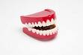
Fill in the gaps using the words below.

Kipper had some funny _________ teeth. The magic key took the children to a ____________. They heard of a ___________ that wouldn’t __________. “We can _________ the princess laugh” said Biff. The _____ ran off with the teeth. The king put the teeth on a ___________. The princess _____ the king and started to laugh. The king ________ funny because he had ______ all over his _____________. “__________ laugh at _______ things”
said Chip.
Name:
__________________________________________________________________________________________________________________________________________________________________________________________________________________________________________________________________________________________________________________________________________________________________________________________________________
Design something to make the princess laugh.
Describe what it does below.
Oh Golly! I forgot to add capital letters and full stops! Write out the sentences below with capital letters and full stops so that they are easy to read. There are 2 sentences in each question.

1. kipper had some joke teeth the joke teeth were new
__________________________________
____________________________________________________________________

2. the dog was too fast nobody could catch it
__________________________________
__________________________________________________________________________________________

3. the king had mud on his clothes he had the teeth on the cushion
_______________________________________________________________________________________________________________________________________
Name:
The princess heard the noise. She started to laugh.
princess laugh book

put teeth joke

saw went ran

mouth king picked
Choose 3 verbs above and write sentences using these verbs.
_________________________________________________________________________________________________________________________________________________________________________________________________________________________________
Circle the doing words below.
Heard and laugh are verbs. Verbs are doing words. They describe what something or someone did.
Oh no! There is a finger space thief!
Write out the sentences below with finger spaces so that they are easy to read.

Name:

1. BiffandChip toldMumandDad about theswimmingtest. [page 8]
__________________________________

2. MumandDad hada surpriseforthem. [page 9]
__________________________________

3. The magictookthem underwater. [page 18]
__________________________________

4. They blewbubbles attheoctopus. [page 18]
__________________________________

5. It was atreasurechest andit was fullofgold. [page 26]
__________________________________

6. Thechildren rantolook inthefish tank. [page 24]
__________________________________

Fill in the rest of the sentences to answer the questions.
Remember to add full stops at the end of each sentence.

Now read the sentences to make sure they make sense.

1. What test did the children take? [page 2]

The children were taking a __________________

2. What did the children have to pick up in the pool? [page 5]

The children had to ________________________

3. Where did the magic take the children [page 18]

The magic took____________________________

4. How did the children get the octopus to move from the chest? [page 25]]

The children _____________________________
_______________________________________

5. What was your favourite part of the story?

My favourite part _____________________
____________________________________________________________

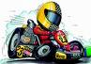
Answer these questions in full sentences in your literacy book.

Remember to start your sentences with capital letters and remember to end your sentences with full stops.

Eg. Where did mum find the go-kart?
Mum found the go-kart in the shed.

1. Who did Biff tell about the race? [page 2]

2. Describe the go-kart mum found in the shed. [page 3]

3. What did Dad decide to do? [page 4/5]

4. Why could Biff not ride in the new go-kart straight away? [page 7]

5. What did Wilma and Anneena do? [page 12]

6. How do you think Wilma and Anneena felt after the crash? [page 13/14]

7. Why do you think the children called the new go-kart
Silver Bullet?

Name:
Turn to page 6 and 7 in ‘The Go-Kart Race’.

Make a list of as many verbs you can see in the picture.
You’re a star! Well done!
Write a sentence using 2 or more of the verbs above.
_________________________________________________
_________________________________________________
Remember capital letters and full stops.
Silly me! I forgot to put capital letters and full stops in my sentences so that they make sense.

Can you help me add capital letters and full stops to the sentences below so that they make sense.
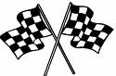
1. mum found a rusty go kart

2. they went to the park

___________________________________________

3. wilma and Anneena had a race
___________________________________________

4. the go-karts raced down the hill

___________________________________________
Name:

Draw pictures and write sentences below them to retell the story of ‘The Go-Kart Race’.
___________________

___________________

___________________

___________________

___________________

___________________

___________________

___________________

Name:

___________________

___________________

___________________

___________________
C
Design your own go-kart below. List as many adjectives as you can to describe your go-kart.
______________________________________________________
______________________________________________________
_______________________________________________________________________

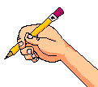
Name:
jokesilly lookedmudsaw

villageclotheslaughcushion

princessmakedogPeople
The Laughing Princess
Fill in the gaps using the words below.

Kipper had some funny _________ teeth. The magic key took the children to a ____________. They heard of a ___________ that wouldn’t __________. “We can _________ the princess laugh” said Biff. The _____ ran off with the teeth. The king put the teeth on a ___________. The princess _____ the king and started to laugh. The king ________ funny because he had ______ all over his _____________. “__________ laugh at _______ things”
said Chip.
Name:
The princess heard the noise. She started to laugh.
princess laugh book

put teeth joke

saw went ran

mouth king picked
Choose 3 verbs above and write sentences using these verbs.
_________________________________________________________________________________________________________________________________________________________________________________________________________________________________
Circle the doing words below.
Heard and laugh are verbs. Verbs are doing words. They describe what something or someone did.
Oh Golly! I forgot to add capital letters and full stops! Write out the sentences below with capital letters and full stops so that they are easy to read. There are 2 sentences in each question.

1. kipper had some joke teeth the joke teeth were new
__________________________________
____________________________________________________________________

2. the dog was too fast nobody could catch it
__________________________________
__________________________________________________________________________________________

3. the king had mud on his clothes he had the teeth on the cushion
_______________________________________________________________________________________________________________________________________
Name:
Oh no! I forgot to add finger spaces!
Write out the sentences below with finger spaces so that they are easy to read.

1. Dadput up somedecorations. [page 2]
__________________________________

2. Thechildren wereexcited. [page 8]
__________________________________

3. Thechildrenlooked forFatherChristmas. [page 12]
__________________________________
__________________________________

4. FatherChristmashadnodinner. [page 17]
__________________________________
__________________________________

5. WilfandWilma madesome strawberryjamsandwiches. [page 22]
__________________________________
___________________________________

6. Thewhatsitwas asnookertable. [page 24]
__________________________________
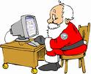
Name:
Answer these questions in full sentences.
Fill in the rest of the sentences to answer the questions.
Remember to add full stops at the end.

If you could take Santa on an adventure what would you do?
___________________________________________________________________________________________
Why did the children feel sorry for Santa?
_____________________________________________________________________________________________________________

1. What did Kipper want for Christmas? [page 8]

Kipper wanted a _________________________

2. What was Santa doing when the children found him? [page 13]

Santa was _______________________________

3. What did Wilma and Chip make for Santa? [page 20]

Wilma and Chip made _______________________

4. What was the whatsit used for? [page 20/21]

The whatsit was used ______________________

5. What was your favourite part?

My favourite part _____________________
____________________________________________________________

said pantomimesang

wantedroundput

andhid locked

the were
Robin Hood
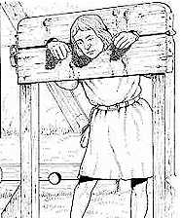
The children went to a _______________ about Robin Hood. The Sheriff ________ to lock him up.
He ____ a rope __________ Robin Hood’s neck. The children ______ put on a cart whilst Kipper ____ in a pot. Kipper _________ a man in the stocks and freed _____ children. Robin hood ______ the children _____ a song. “Thanks,” said Robin Hood. “Aaaaaaah!” _______ Kipper.
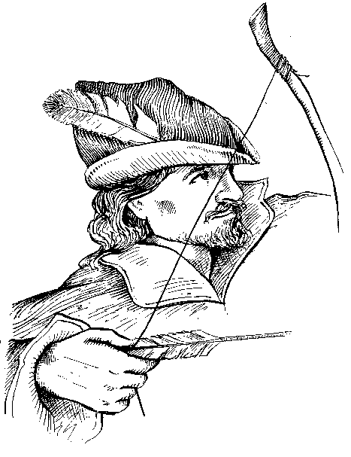
Name:
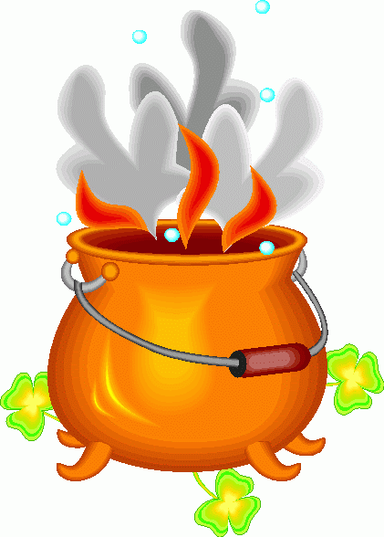
Looked is underlined because it is a verb. A verb is a doing word. It describes what someone or something did.

went pantomime friend

with lived bad

sang took good

sat Robin pot
Choose at least 3 verbs above. Write 3 sentences using these verbs.
__________________________________________________________________________________________________________________________________________________________________________________________________________________________________________________________________________________________________
Circle the verbs below.
Kipper looked inside a big pot.

